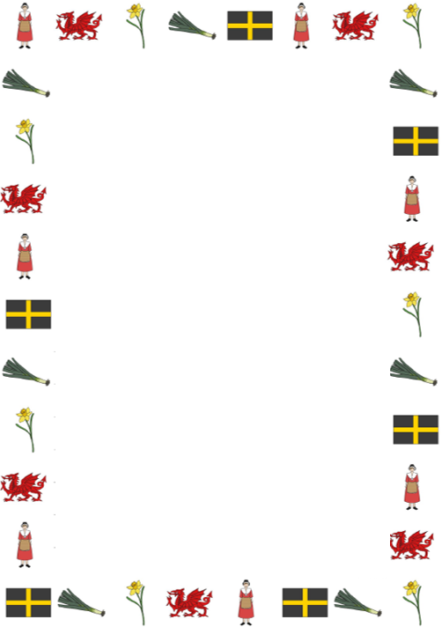
Converting measurements by dividing by 10

Learning Objective: To convert from millimetres to centimetres.
Task: Change the measurements below from millimetres to centimetres by dividing by 10.

- 10 mm =
- 30 mm =
- 70 mm =
- 90 mm =
- 140 mm =
- 180 mm =
- 200 mm =
- 210 mm =
- 220 mm =
- 250 mm =
- 300 mm =
- 10.5 mm =
- 30.5 mm =
- 70.5 mm =
- 80.2 mm =
- 80.8 mm =
- 90. 3 mm =
- 20. 6 mm =

