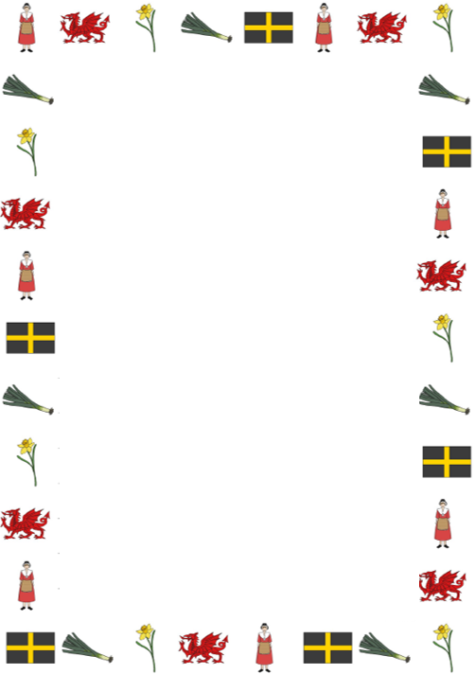
Converting measurements by dividing by 10

Learning Objective: To convert from millimetres to centimetres.
Task: Change the measurements below from millimetres to centimetres by dividing by 10.

- 10 mm = cm
T | U | . | Tth
1 | 0

- 50 mm = cm
T | U | . | Tth
5 | 0

- 70 mm = cm
T | U | . | Tth
7 | 0

- 90 mm = cm
T | U | . | Tth
9 | 0

- 100 mm = cm
H | T | U | . | Tth
1 | 0 | 0

- 120 mm = cm
H | T | U | . | Tth
1 | 2 | 0

- 130 mm = cm
H | T | U | . | Tth
1 | 3 | 0

- 160 mm = cm
H | T | U | . | Tth
1 | 6 | 0

- 200 mm = cm
H | T | U | . | Tth
2 | 0 | 0

- 240 mm = cm
H | T | U | . | Tth
2 | 4 | 0

- 250 mm = cm
H | T | U | . | Tth
2 | 5 | 0

- 280 mm = cm
H | T | U | . | Tth
2 | 8 | 0

