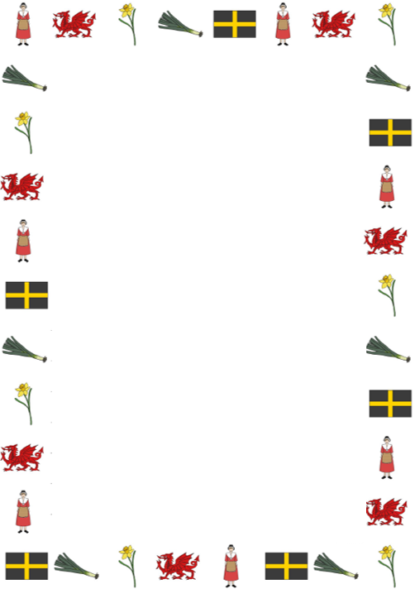
Converting measurements by dividing by 10

Learning Objective: To convert from millimetres to centimetres.
Example:
What is 70 mm as cm?
70 $÷$ 10 = 7 cm
Move the number one decimal places to the right.
T | U | . | Tth
7 | 0 | .
 | 7 | . | 0

- 120 mm = cm
H | T | U | . | Tth
1 | 2 | 0

- 150 mm = cm
H | T | U | . | Tth
1 | 5 | 0

- 20 mm = cm
T | U | . | Tth
2 | 0

- 180 mm = cm
H | T | U | . | Tth
1 | 8 | 0

- 100 mm = cm
H | T | U | . | Tth
1 | 0 | 0

- 10 mm = cm
T | U | . | Tth
1 | 0

- 30 mm = cm
T | U | . | Tth
3 | 0

- 50 mm = cm
T | U | . | Tth
5 | 0

- 60 mm = cm
T | U | . | Tth
6 | 0

- 80 mm = cm
T | U | . | Tth
8 | 0

Task: Change the measurements below from millimetres to centimetres by dividing by 10.

