Converting measurements by dividing by 100

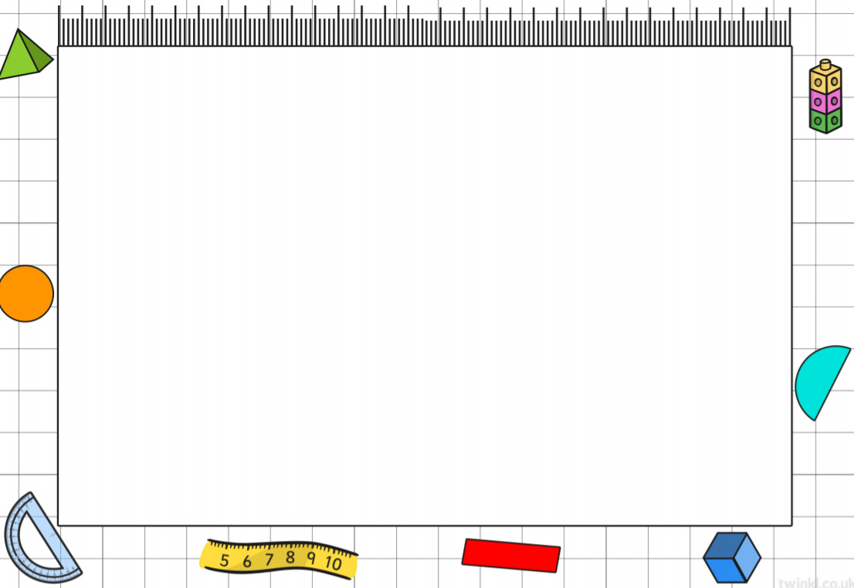
Learning Objective: To convert from centimetres to metres.
Task: Change the measurements below from centimetres to metres.
- 200 cm =
- 230 cm =
- 760 cm =
- 830 cm =
- 450 cm =
- 380 cm =
- 550 cm =

Task: Answer the worded questions to find the measurement in metres.
- Mary buys 30 rulers with a total length of 300 cm. What is this in metres?

- Tom wants to buy a car that is 5 metres long. The car he is looking at is 550 cm long. Is the car long enough for Tom?

- Lewis buys a tv that is 150 cm long. What is this in metres?

Task: Work out if these statements are right or wrong. Remember to say why.
- John believes 600 cm of wood is the same as 7 m of wood. Is this right or wrong?

- Wendy does not believe John and thinks that 700 cm is the same as 7 m of wood. Is this right or wrong?

- Tina thinks that 480 cm of wood is long enough for two doors. The doors are 2 metres each. Is tina right or wrong?

