Converting measurements by dividing by 100

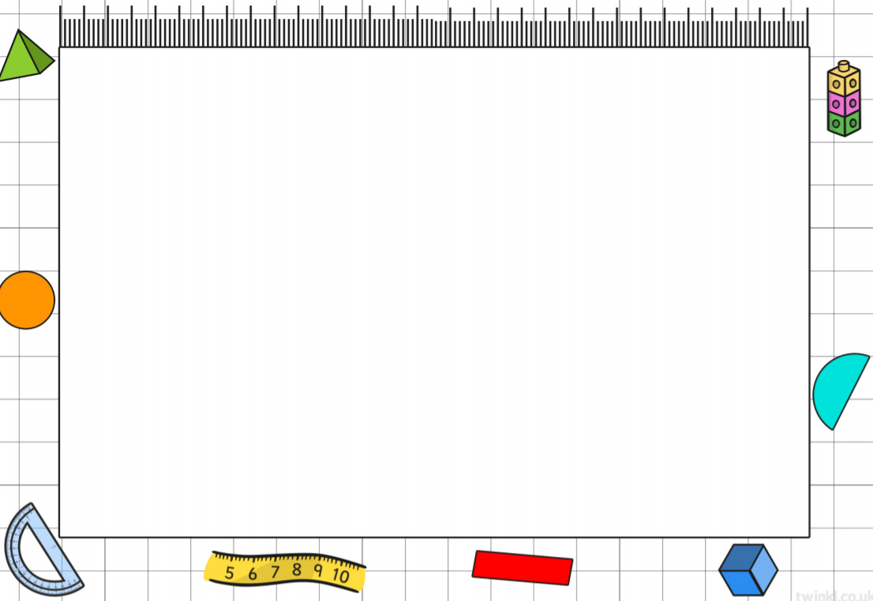
Learning Objective: To convert from centimetres to metres.
Task: Work out the conversion from centimetres to metres. Highlight the correct answer.

300 cm = m
3.5 m | 3.2 m | 3 m | 4 m

220 cm = m
2.1 m | 2.3 m | 2.2 m | 5 m

180 cm = m
1.7 m | 1.8 m | 5.2 m | 1.7 m

460 cm = m
4.6 m | 4 m | 3.5 m | 4.5 m

700 cm = m
7 m | 7.2 m | 7.1 m | 6.9 m

Task: Complete the conversions from centimetre to metres by dividing by 100.

- 530 cm =
- 250 cm =
- 670 cm =
- 430 cm =
- 590 cm =

