Converting measurements by dividing by 100

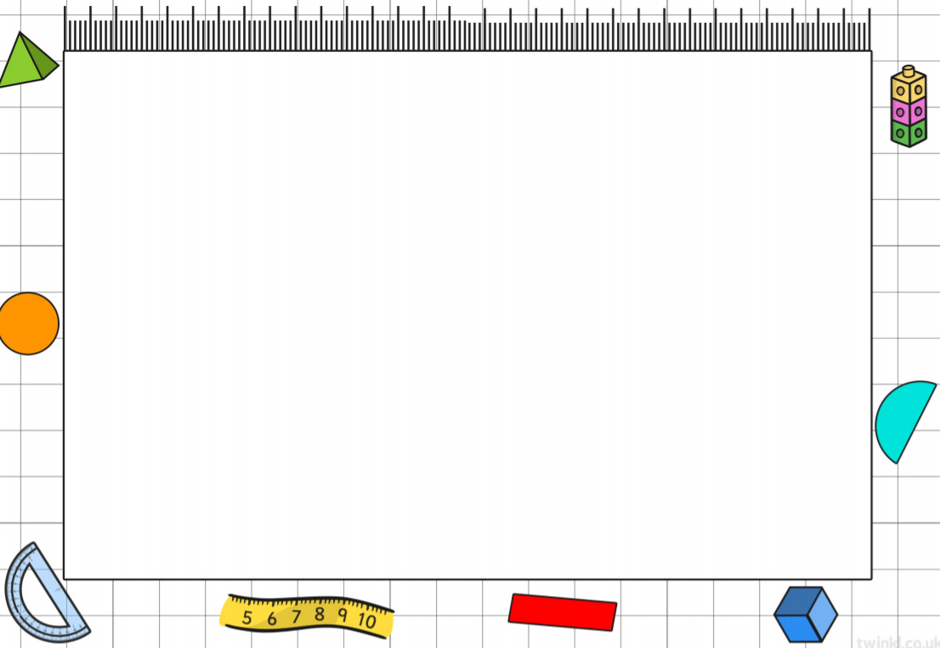
Learning Objective: To convert from centimetres to metres.

- 240 cm = m
H | T | U | . | Tth
2 | 4 | 0

- 310 cm = m
H | T | U | . | Tth
3 | 1 | 0

- 100 cm = m
H | T | U | . | Tth
1 | 0 | 0

- 150 cm = m
H | T | U | . | Tth
1 | 5 | 0

Example:
What is 120 cm as m?
120 $÷$ 100 = 1.2 m

Move the number two decimal place to the right.
H | T | U | . | Tth
1 | 2 | 0 | .
 |  | 1 | . | 2
Task: Change the measurements below from centimetres to metres by dividing by 100.
Task: Match the measurements that are the same in centimetres and metres.

8 m

2.5 m

5 m

4.2 m

800 cm

420 cm

250 cm

500 cm

