Support sheet
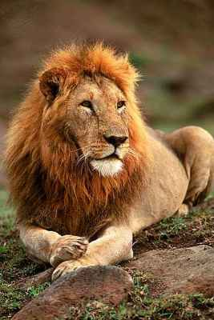
Learning objective: To write a fictional narrative using imagination and appropriate vocabulary.
Similes: A simile compares one thing to another.
For example: as strong as a lion.

Metaphors: This is a word that is used to describe somethings as if it were another thing.
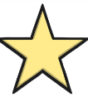
For example: John is a star.

Alliteration: Alliteration is when words start with the same sound.
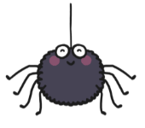
For example: scary spiders.

Personification: Personification describes objects as if they are people.
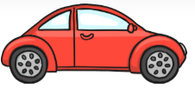
For example: the new car danced down the road.


Onomatopoeia: Onomatopoeia is a word that sounds like what it means.
For example: the corn went pop in the microwave.
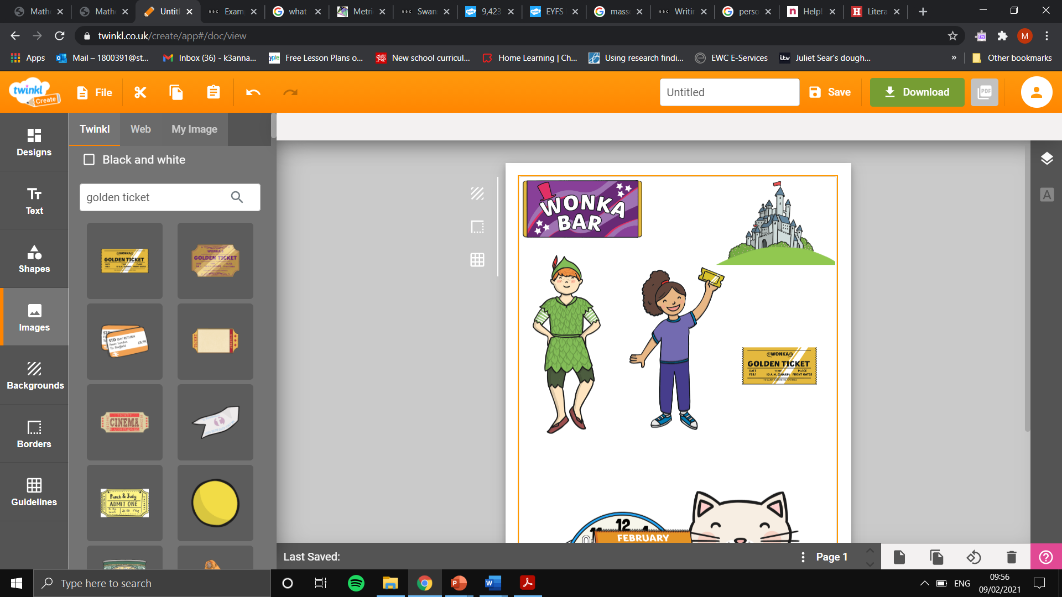
Elements of a story
Characters: Characters are the people, animals, or fantasy characters in a story.
For example: Harry Potter, Matilda, Charlie Bucket and Peter Pan.
Settings: The setting is the place where a story takes place.
For example: Hogwarts, school, home, Willy Wonka’s Chocolate Factory and Neverland.

Plot: The plot is used to describe the main events of a story.
For example: In Charlie and the Chocolate Factory, Charlie Bucket and Grandpa Joe win a golden ticket to tour Willy Wonka’s Chocolate Factory alongside other contest winners. Wonka has a hidden motivation for the tour. He plans to give his factory away to one of the contest winners after they show their true colours.
Conflict: A conflict is a problem that needs to be solved in the story.
For example: In Charlie and the Chocolate Factory, the main conflict is which of the 5 golden ticket winners will receive Wonka’s chocolate factory and fortune. This problem is solved when Charlie Bucket wins Wonka’s contest and the factory.
Theme: The theme of a story is the underlying meaning or main points explored in the story.
For example: Greed is the theme in Charlie and the Chocolate Factory. The story shows all the contests being greedy for instance, Violent is greedy for gum.

