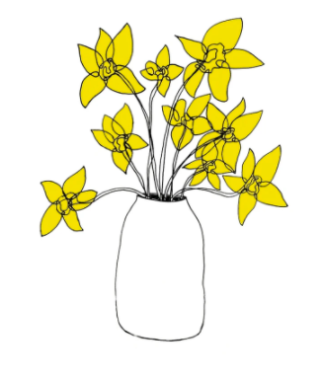

These digital dafs are by the Artist Carissa Tanton.
(I think they are amazing)

