The Trail Blazing Time Machine to the Fantastic Future
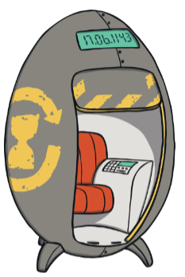
The thrilling, tremendous, time bending time machine

The first of its kind. This amazing time machine is like nothing you have seen before. This time machine will zoom you into the fantastic future in a flash and back in a bolt. This is the Time machine 1000. This time machine is one of a kind. Fitted with leather seats and automatics doors, this is the only way to travel to the future. Can you afford not to buy a journey to the future in the Time machine 1000. This is the world only and greatest time machine to travel to the future.
The fantasy future is full of glorious gadgets and awesome technology. I can not wait to go, can you? One future traveller said, “The future is like nothing you have seen before. This journey into the land of flying cars and real-life robots is a one in a lifetime journey. It was amazing.”
The positive reviews for this time machine and trip are out of this world. “Look no further! This is the best thing I have ever tested. What more could you want?” (Tim, 10, Swansea). Even Elon Musk was impressed. He said, “Wow! This is amazing. To the future and beyond.”
Special offer - For today only! Buy this journey to the future in the Time machine 1000 for only £1,000,000. What a bargain. Be one in a billion and travel to the future!

