“Deforestation should be banned”
Discuss this statement to find points that agree and disagree with this statement.
Agree | Disagree
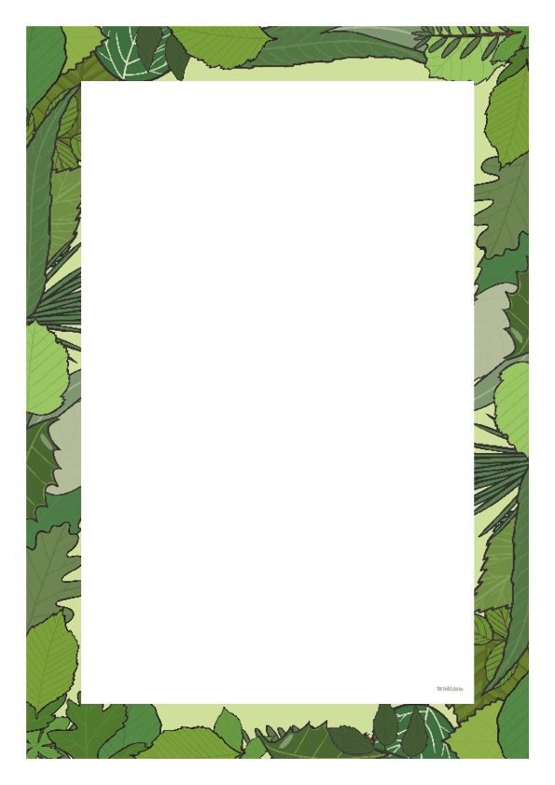
Deforestation Debate
Learning objective: To identify the main views and points surrounding deforestation within a structured argument.
Task: Complete the table, identify reasons for and against deforestation using your previous readings and the fact file.

