
Connectives and Sentence Starters
Connectives
- And
- In addition
- Also
- As well as
- In addition
- Firstly
- Finally
- Likewise
- Similarly
- However
- Despite this
- Yet
- On the other hand
- For example
- For instance
- Because
- As a result
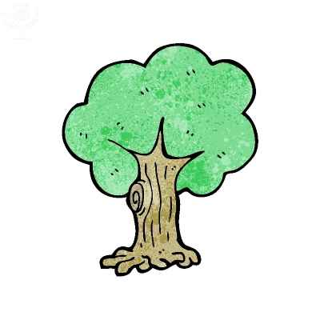



Sentence starters
- An argument for deforestation is …
- An argument against deforestation is…
- One reason why deforestation should be/ should not be banned is because…
- A reason against/ for deforestation is…
- Deforestation is …

