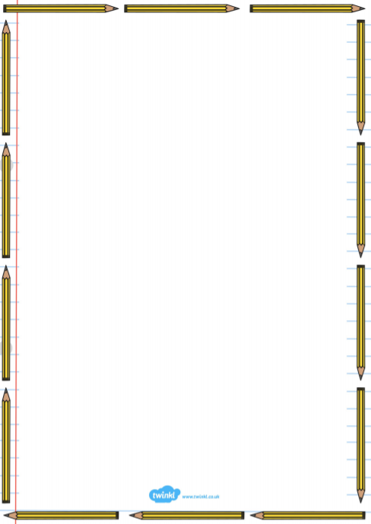
Persuasive Writing Help Sheet
This help sheet works to help you with the areas you found hard or challenging in your self-reflection sheets.
Persuasive techniques
Persuasive technique | Meanings | Examples
Rhetorical questions | A question that does not need to be answered but is used to get the reader thinking. | Do you want to travel to the future?  What more could you want?
Exaggeration | This is when something is said to be better or worse than it actually is. | This is the best thing in the world.
Emotive language | Language that causes strong feelings in the reader. | Magical, wonderful and heavenly.
Direct language | Words to make the reader feel special and connected like you and your. | You can travel to the future. Today! This is your ride to the future.
Personal language | This is when the writing is kept friendly and personal. The tone that is used in your writing is personal and makes the reader feel involved. This is the overall personal and friendly feel to the piece of writing not just the use of you or your like in direct language. | Many time travellers, like yourself, will love this amazing time machine.
Anecdotes | A real-life funny or interesting story that lets the reader get to know the writer. | John once tried to travel to the future in a phone box but, it did not go anywhere. The Time machine 1000 however, will take you to the future in a flash.
Repetition | When a word is repeated for effect. | Buy this journey before it is too late. Now is your time to buy before it goes. But! Buy! Buy!
Undermine | This is when alternative opinions are given and are tried to be disproved. | Many people do not believe you can travel to space but, just ask one of our ask time travellers Elon Musk. He though the journey was a “once in a lifetime experience!”
Facts or statistics | These are facts or numbers that are used to persuade the reader. These can be used to persuade because they are difficult to argue with and create a strong argument. | For example, NASA has sent five Mars rovers to Mars.

