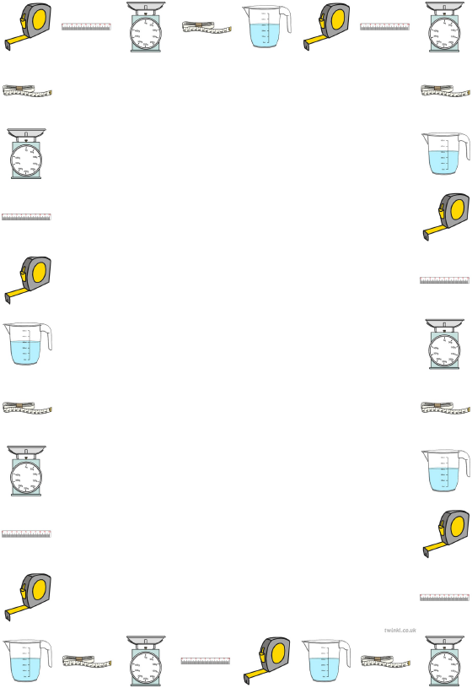
Converting measurements by dividing by 1000

Learning Objective: To convert measurements by multiplying by dividing by 1000.
Task: Convert the measurements by dividing by 1000.
Metres (m) to Kilometres (Km)
6000 m
6500 m
6300 m
6800 m
7500 m

Grams (g) to Kilograms (Kg)
7000 g
2600 g
6290 g
9300 g
1230 g

Millilitres (ml) to Litres (L)
2000 ml
3800 ml
7600 ml
2700 ml
2250 ml

