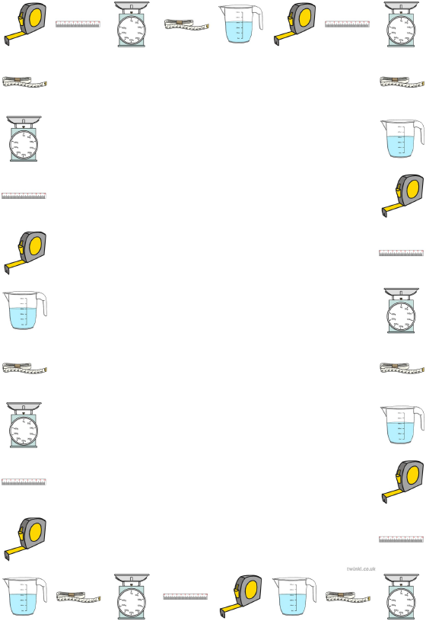
Converting measurements by dividing by 1000

Learning Objective: To convert measurements by multiplying by dividing by 1000.
Task: Convert the measurements by dividing by 1000.
Metres (m) to Kilometres (Km)
4000 m
9000 m
7000 m
3500 m
5500 m

Grams (g) to Kilograms (Kg)
3000 g
5000 g
6000 g
1500 g
4500 g

Millilitres (ml) to Litres (L)
1000 ml
2000 ml
8000 ml
6500 ml
9500 ml

