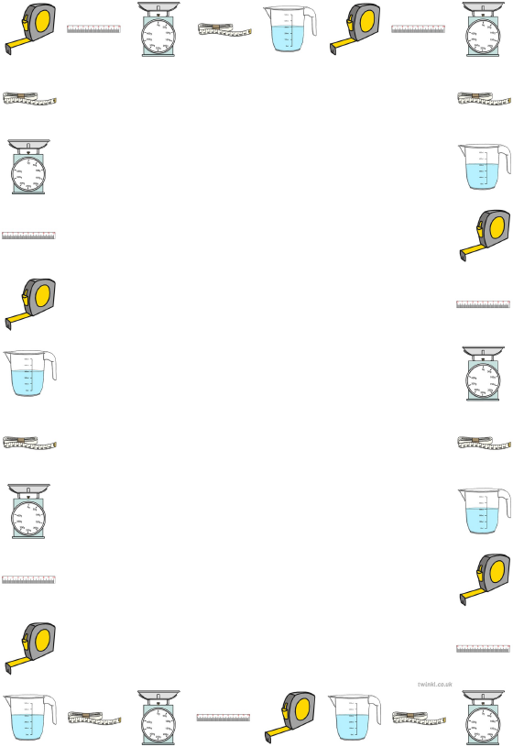
Converting measurements by dividing by 1000

Learning Objective: To convert measurements by multiplying by dividing by 1000.

Task: Convert the measurements by dividing by 1000.

Metres (m) to Kilometres (Km)
1000 m
5000 m
4000 m

Grams (g) to Kilograms (Kg)
3000 g
6000 g
8000 g

Millilitres (ml) to Litres (L)
9000 ml
2000 ml
7000 ml

