Converting measurements by dividing

Learning Objective: To convert a range of measurements through division.
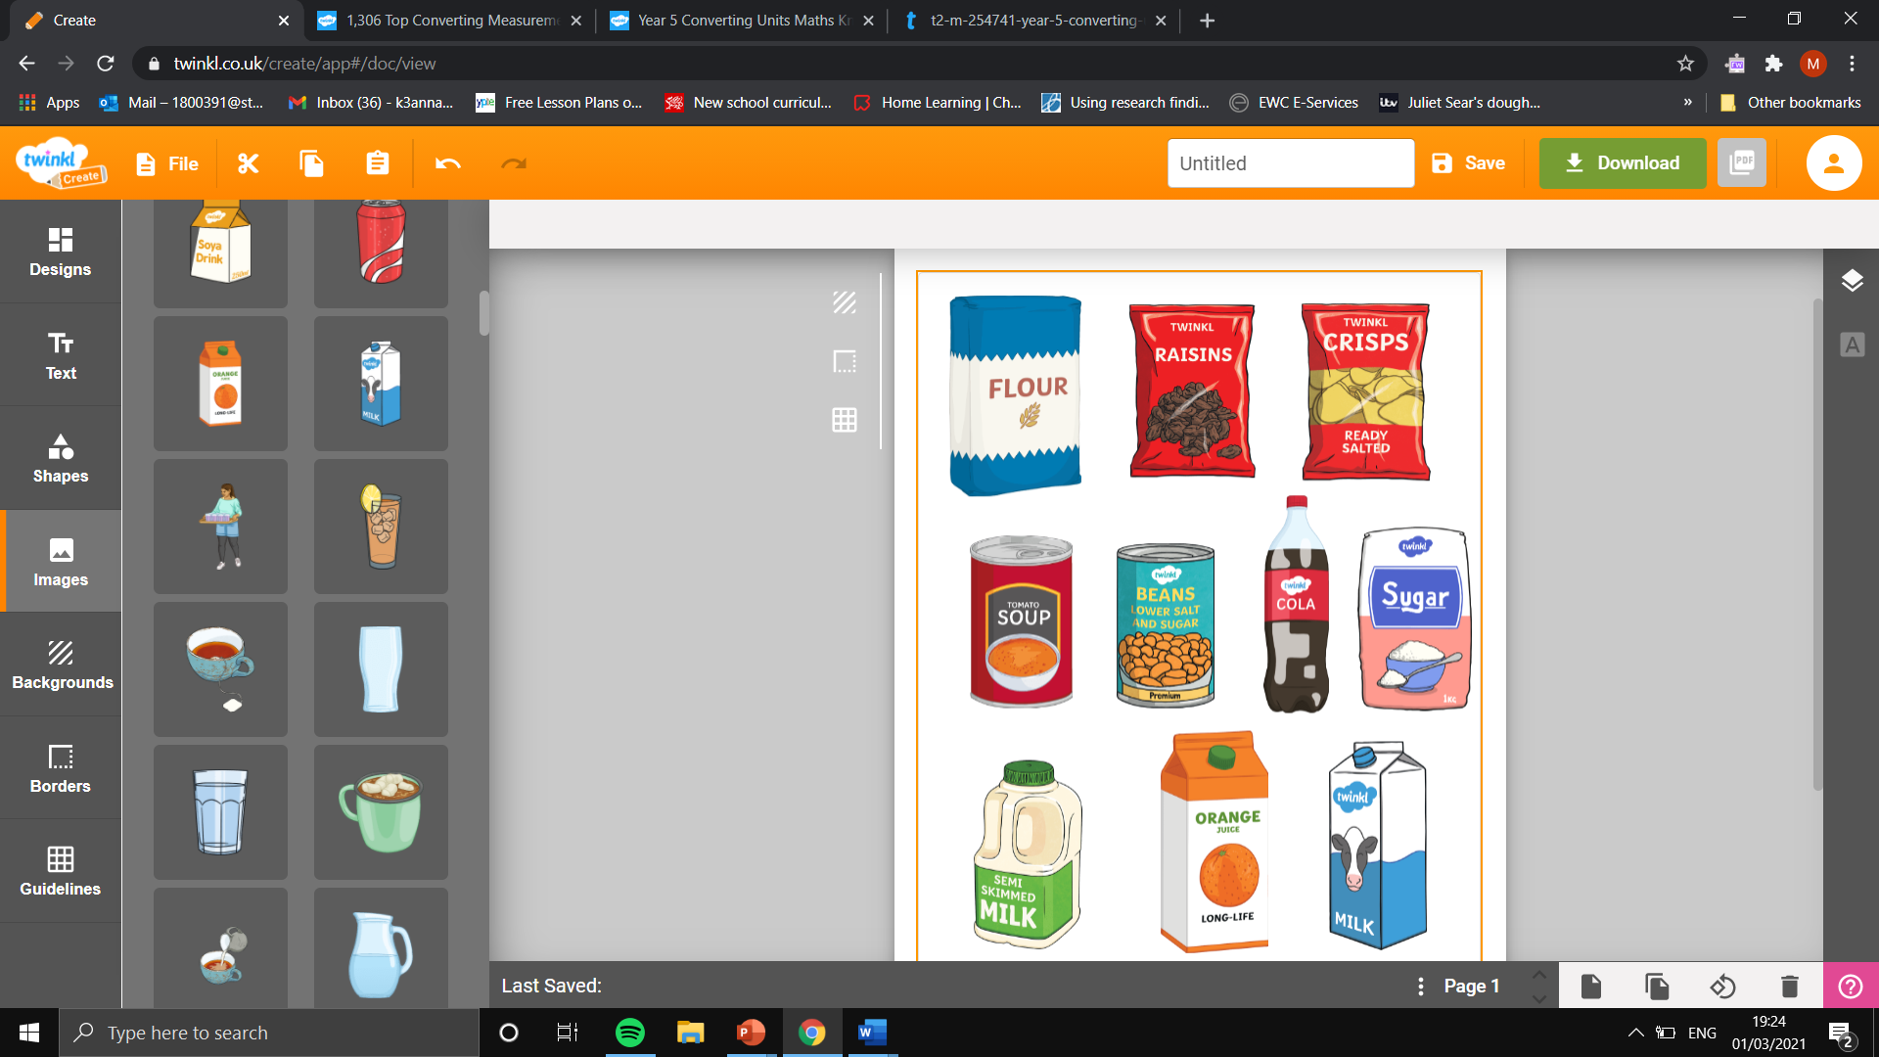
Task: Convert the measurements by dividing by 1000.
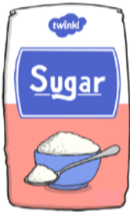

Flour
2000 g
Kilograms:
Sugar
1500 g
Kilograms:
Raisins
5500 g
Kilograms:
Beans
1000 g
Kilograms:

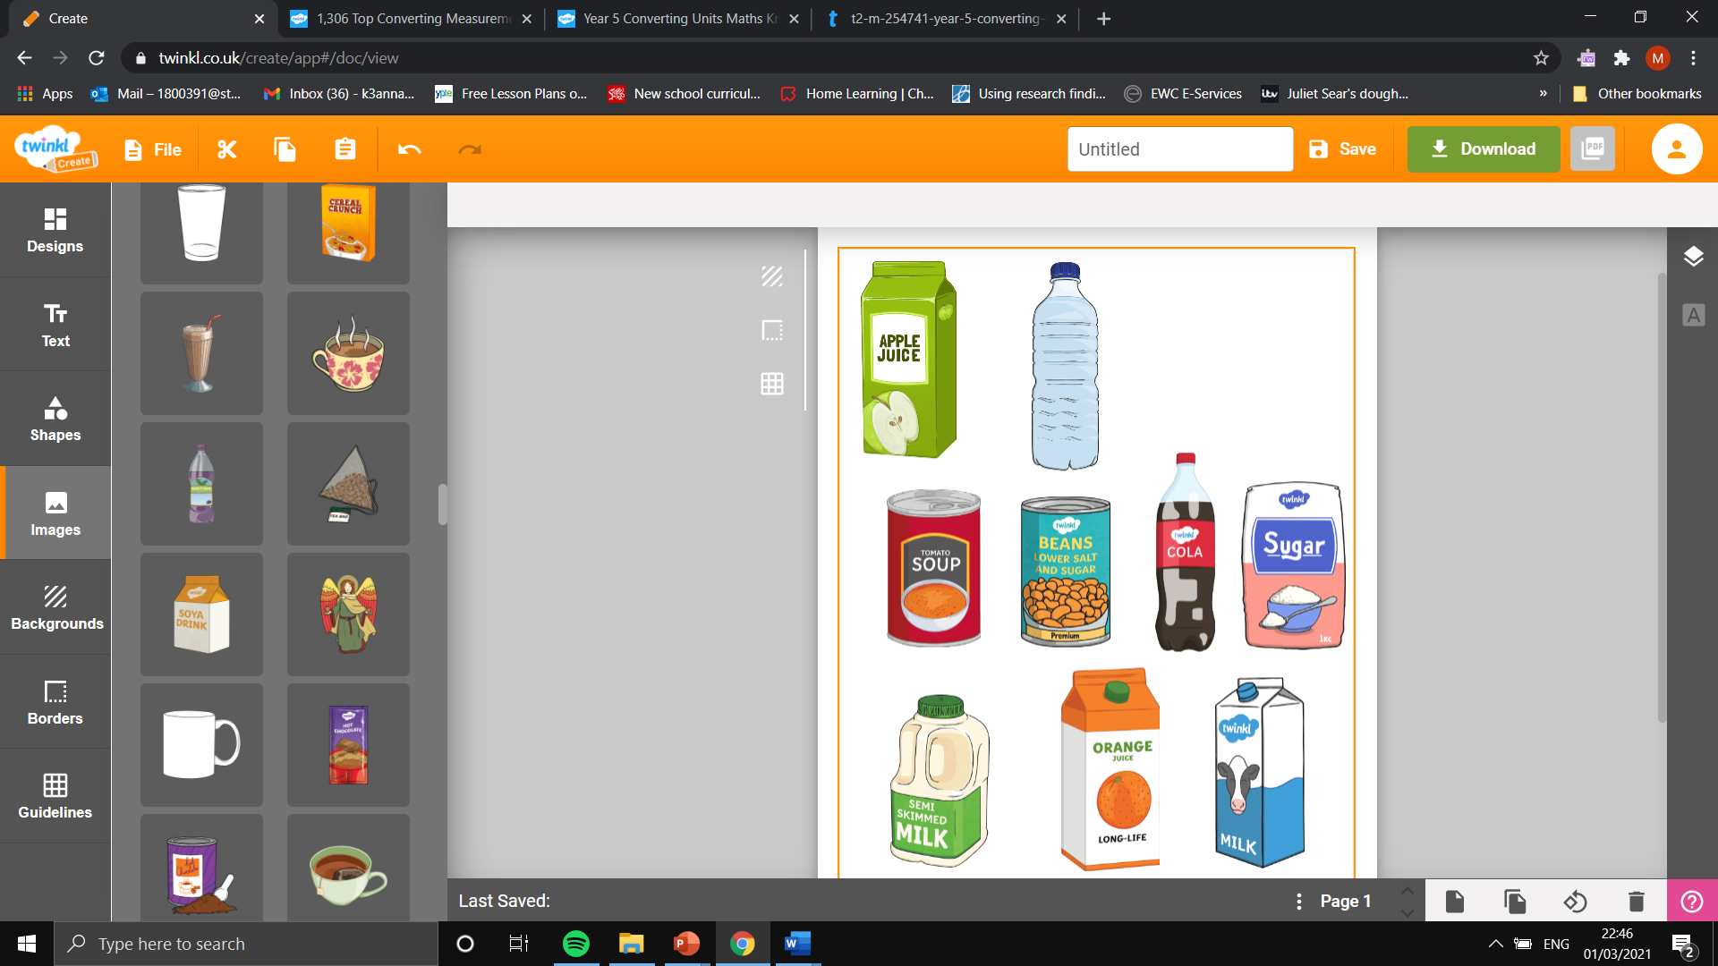

Cola
1250 ml
Litres:
Water
1000 ml
Litres:
Apple Juice
1500 ml
Litres:
Milk
2750 ml
Litres:

Task: Convert the lengths to the new measurements in the table.

Centimetres  (cm) | Metres  (m)
500 cm
707 cm
201 cm
Metres  (m) | Kilometres  (km)
2000 m
7300 m
8200 m
Millimetres (mm) | Centimetres  (cm)
60 mm
34.5 mm
80. 2 mm

