Converting measurements by dividing

Learning Objective: To convert a range of measurements through division.
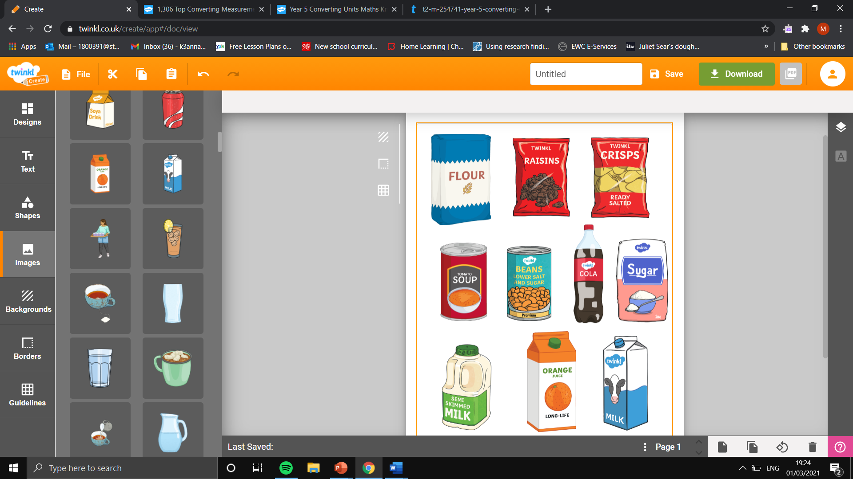
Task: Convert the measurements by dividing by 1000.
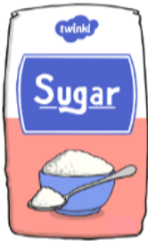

Flour
5000 g
Kilograms:
Sugar
8500 g
Kilograms:
Raisins
7000 g
Kilograms:
Beans
2000 g
Kilograms:

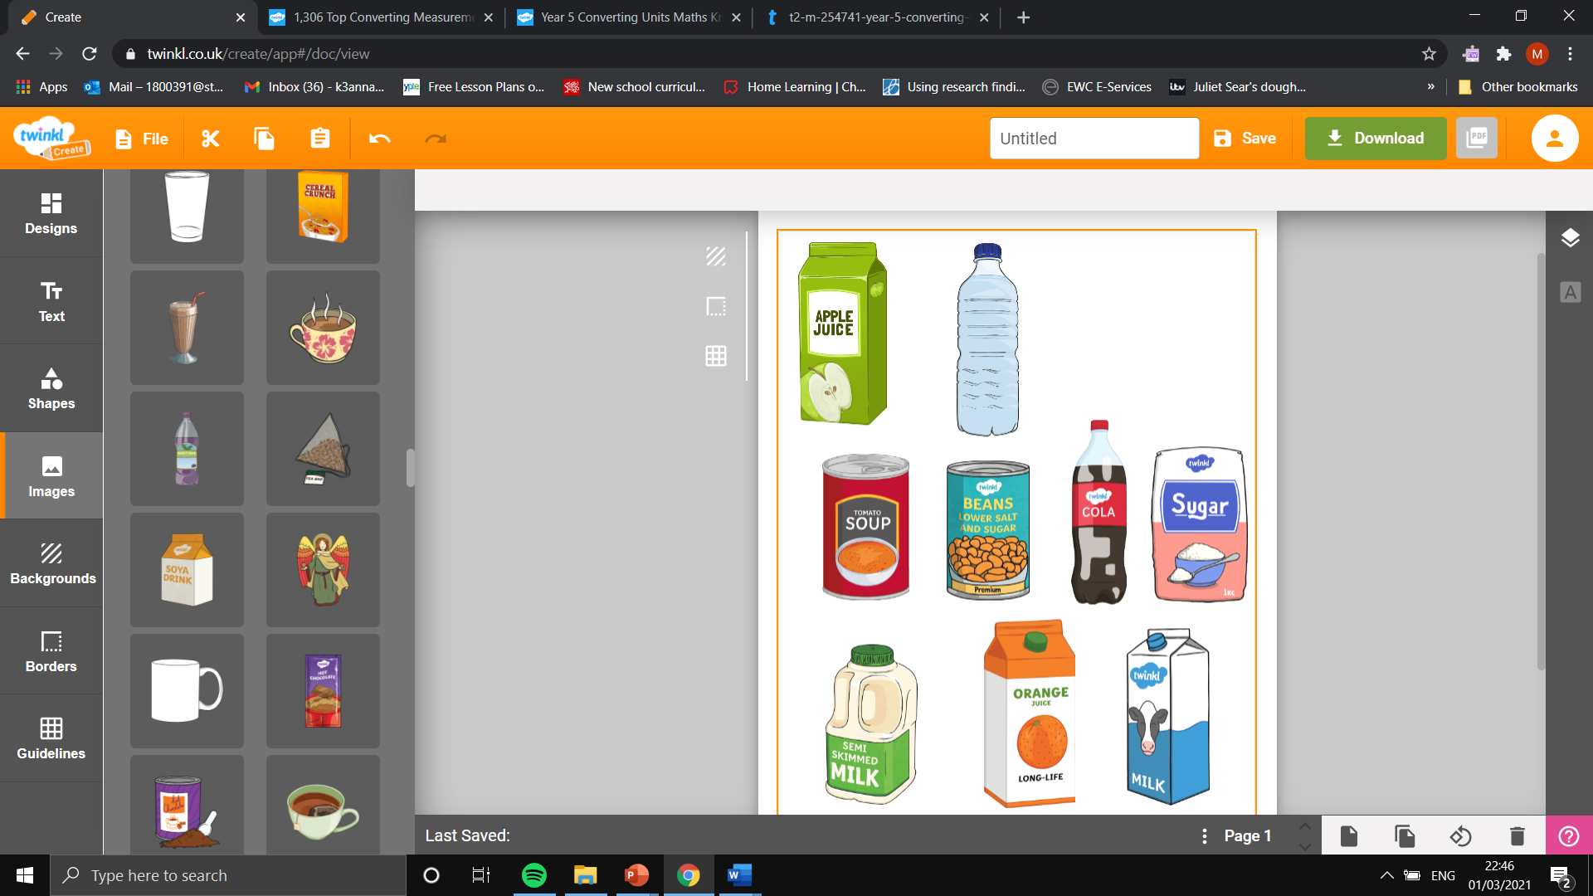

Cola
1500 ml
Litres:
Water
4000 ml
Litres:
Apple Juice
3000 ml
Litres:
Milk
1000 ml
Litres:

Task: Convert the lengths to the new measurements in the table.

Centimetres  (cm) | Metres  (m)
700 cm
400 cm
150 cm
Metres  (m) | Kilometres  (km)
9000 m
2500 m
4200 m
Millimetres (mm) | Centimetres  (cm)
30 mm
59 mm
82 mm

