Converting measurements by dividing

Learning Objective: To convert a range of measurements through division.
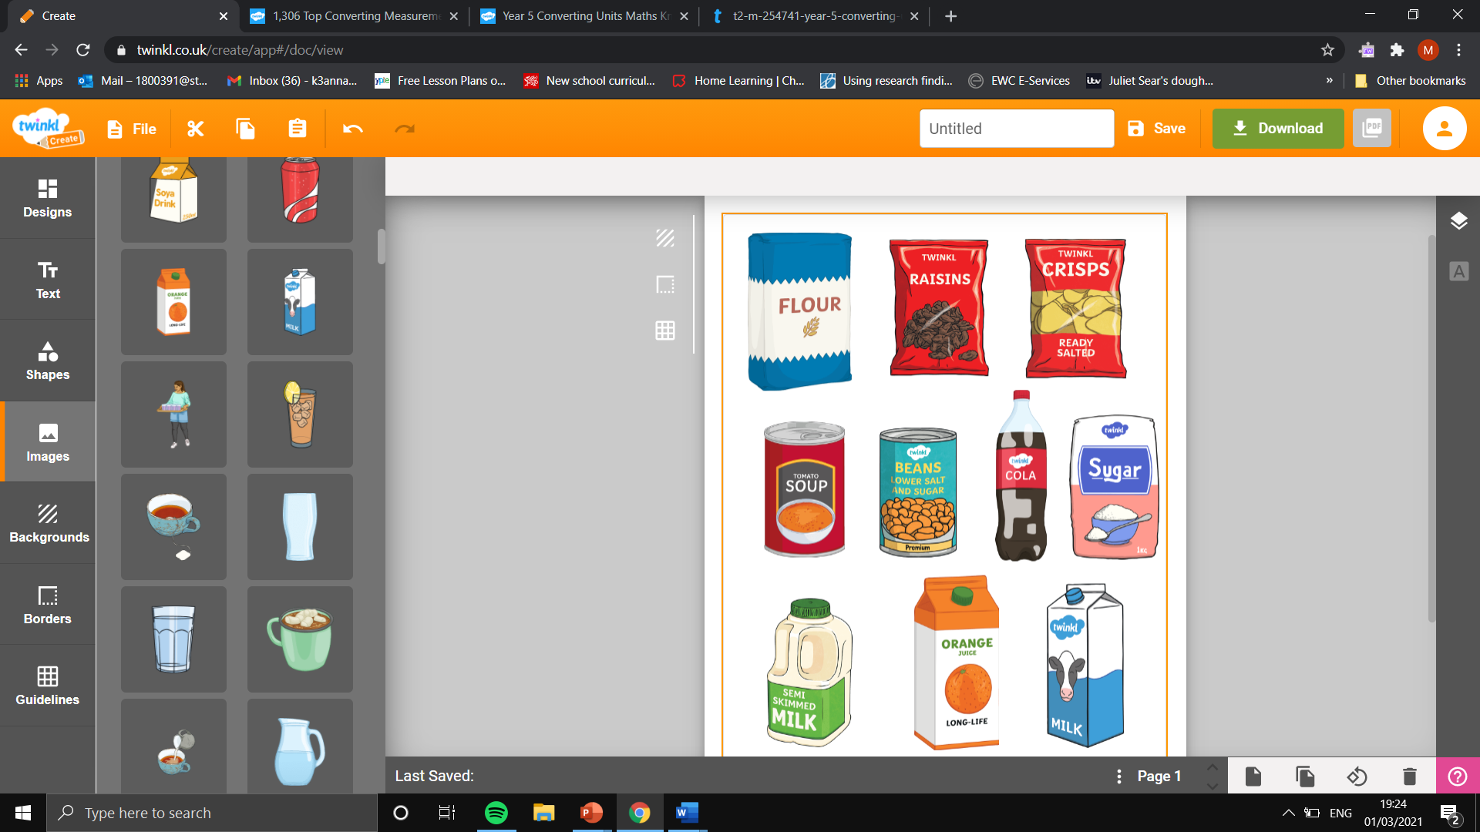
Task: Convert the measurements by dividing by 1000.
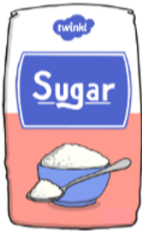

Flour
7000 g
Kilograms:
Sugar
6000 g
Kilograms:
Raisins
5000 g
Kilograms:
Beans
3000 g
Kilograms:

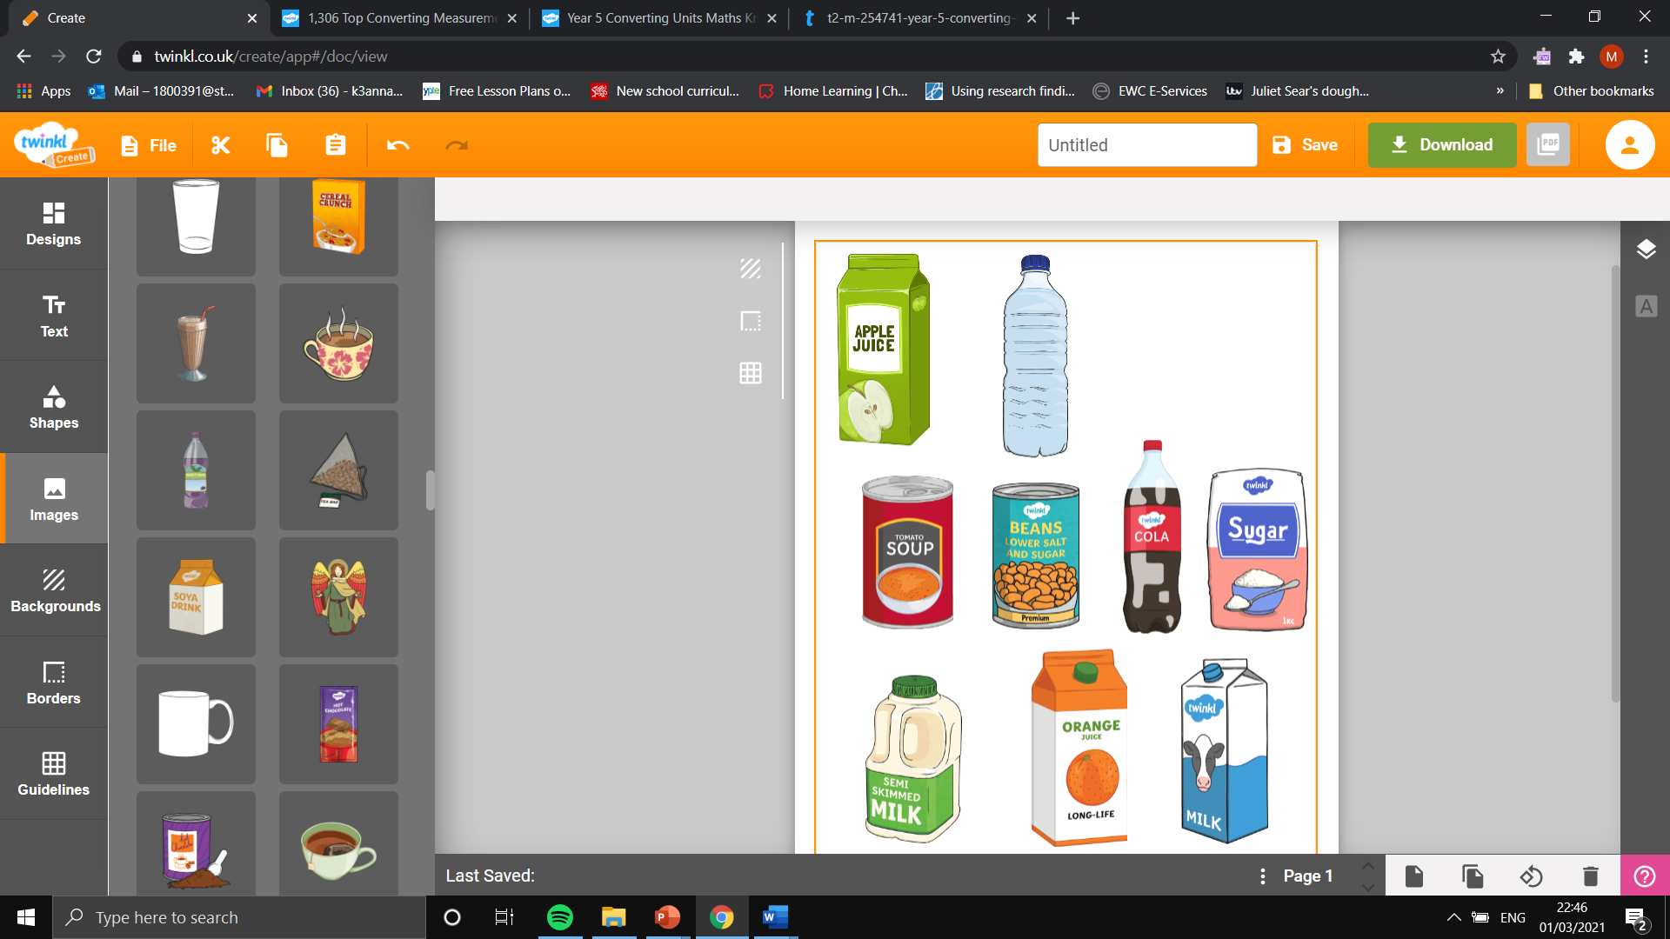

Cola
4000 ml
Litres:
Water
3000 ml
Litres:
Apple Juice
1000 ml
Litres:
Milk
2000 ml
Litres:

Task: Convert the lengths to the new measurements in the table.

Centimetres  (cm) | Metres  (m)
400 cm
700 cm
200 cm
Metres  (m) | Kilometres  (km)
2000 m
8000 m
9000 m
Millimetres (mm) | Centimetres  (cm)
60 mm
30 mm
90 mm

