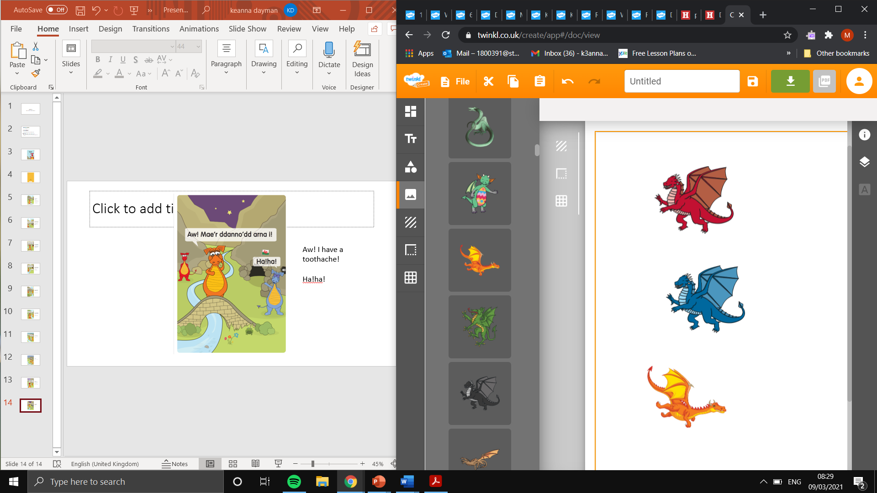
Welsh Book Review
Adolygiad llyfr Cymraeg

Learning Objective: To listen and respond to Welsh book.
What you did you not like about the story? Beth dwyt ti ddim yn hoffi am y stori?
I do not like… Dw i ddim yn hoffi…
What did you like about the story? Beth wyt ti’n hoffi am y stori?
I like … Dw i’n hoffi …
Questions about the story? Cwestiynau am y stori?
- Where does Dora live? Ble mae Dora yn byw?
Dora lives in … Mae Dora yn byw yn…

- Who does she live with? Gyda phwy mae hi'n byw?
She lives with … Mae hi'n byw gyda…

- What does Dora like to eat? Beth mae dora yn hoffi ei fwyta?
She likes to eat… Mae hi'n hoffi bwyta…

- How is Dad feeling? Sut mae Dad yn teimlo?
Dad is feeling … Mae Dad yn teimlo ...
Rate out of ten. Cyfradd allan o ddeg.
…out of ten - …allan o ddeg.

