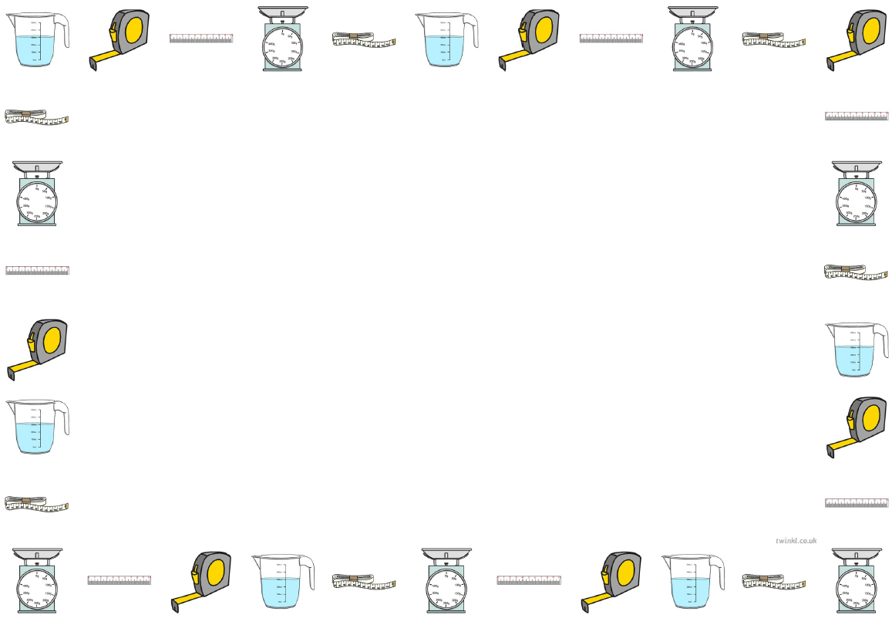
Self-Reflection Form
What did you enjoy about the measurement lessons?
What did you find hard or challenging about the measurement lessons?
Is there anything you would like to improve your understanding of in measurement?
Is there anything else you would like to learn about measurement?

