
Tuesday 8th December

Interpreting Data – Pictograms

Everyone loves cake – I certainly do!
We are going to be looking at data and interpreting it this week we are going to be looking at pictograms. The pictogram is all about cupcakes that were sold during a whole week.

I have created three levels of questions GREEN AMBER RED
(Choose 1 to answer or you can do all three)

I think the best way to answer it is to write your answers in an email and send it to me
HunterM6@hwbcymru.net
Or
You could write it in a Word document or J2E then share it!
Or
Write them on a piece of paper and ask someone to check it!

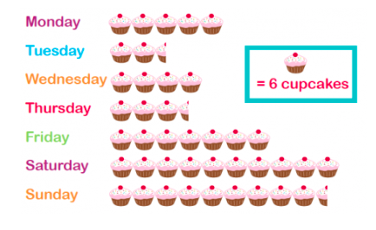

GREEN Questions

- Which day was the least number of cakes sold?
- Which day was the most cakes sold?
- How many cakes were sold on Wednesday?
- How many cakes are worth ½ a cupcake?
- How many cakes we sold on Tuesday?

Remember


AMBER Questions

- Which day has the most cakes sold? (MODE)
- How many cakes were sold on Monday?
- How many cakes were sold on Thursday?
- What day were the least number of cakes sold? How many?
- How many cakes were sold during the Weekend?

Remember

RED Questions

- Which day was the MODE number of cakes sold? And how many?
- How many cakes were sold on Saturday?
- How many cakes were sold over the whole Weekend? (Sat +Sun)
- How many cakes were sold during Monday to Friday?
- How many cakes were sold in total? (Add them all up!)

Remember

Well Done!

-If you want to you could collect your own data and create your own Pictogram you can. You could take a picture of it and email it to me.

Check out tomorrow’s work!

