Thursday 10th December

Interpreting Data – Pie Charts

We are going to be looking at data and interpreting it this week today we are going to be looking at pie charts. The data is all about Christmas Presents delivered around the world. Read the data and answer the questions.

I have created three levels of questions GREEN AMBER RED
(Choose 1 to answer or you can do all three)

I think the best way to answer it is to write your answers in an email and send it to me
HunterM6@hwbcymru.net
Or
You could write it in a Word document or J2E then share it!
Or
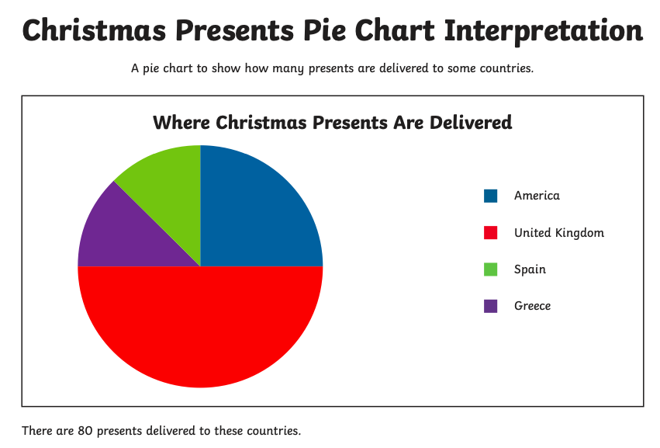
Write them on a piece of paper and ask someone to check it!

Green Questions
So half of it would be?
So half of the half would be?
So half of half of the half would be?

IF 40 PRESENTS WERE DELIVERED IN TOTAL.
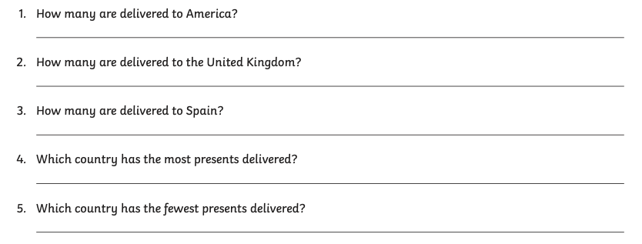

AMBER Questions

REMEMBER THERE ARE 80 PRESENTS DELIVERED
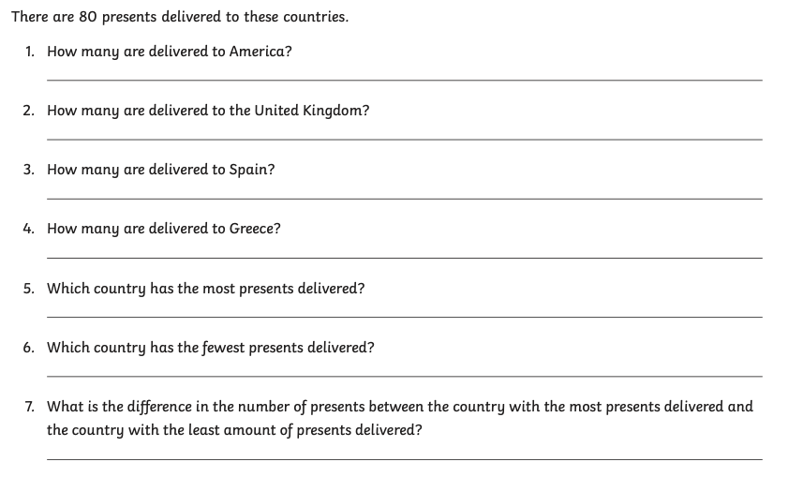

RED Questions

THIS TIME THE TOTAL NUMBER OF PRESENTS DELIVERED IS 120


