Friday 11th December

Problem Solving

This is a really fun Maths Problem – you may need a little help from your parents or older brothers or sisters, you will need a pencil and paper – you can use a calculator if you need to.

Email your final answer to HunterM6@hwbcymru.net

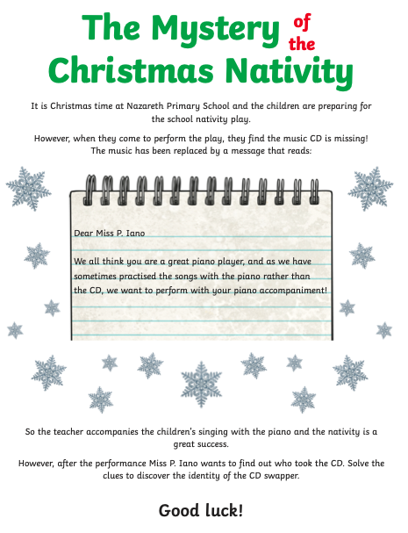
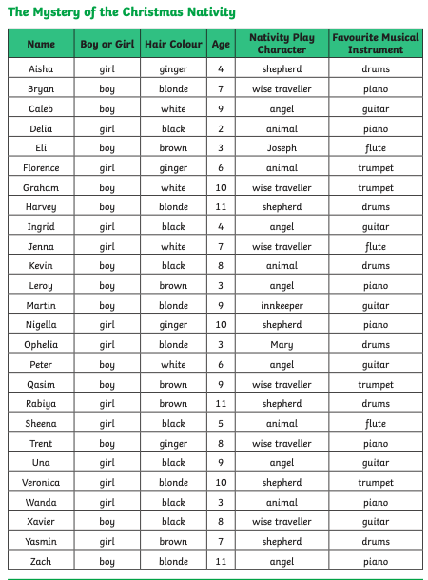
These are all your suspects cross out those you have ruler out!
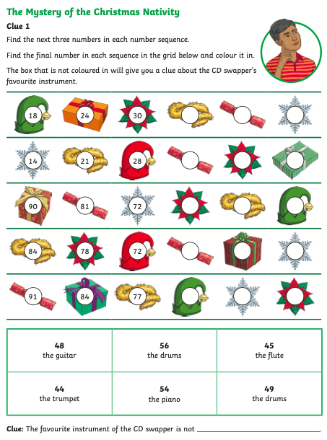
The answer that is not coloured in is…

So you can cross off all the people who’s favourite instrument is………..
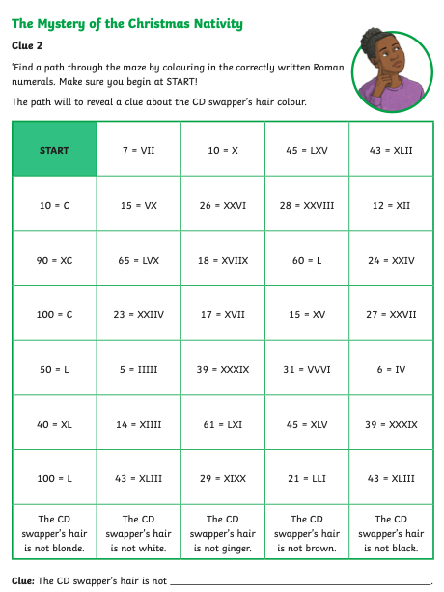
Roman numerals are tricky but fun.
Remember we add numbers on after and take away before.
I = 1. II =2. III =3. IV =4 V = 5. X =10 L = 50 C = 100

Big clue time!!
7 = VII. 10 =X 26 = XXVI 28 = XXVIII 12 = XII. 24 = XXIV
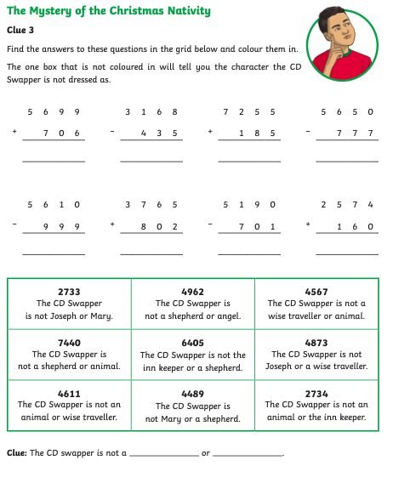
REMEMBER!
You can use a calculator if you want to.
But these are all column addition or subtraction questions.
Start at the units, then tens …
You can count on – or you may need to borrow!
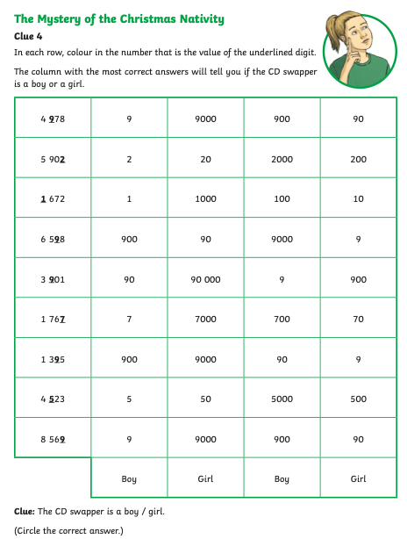
Place Value

You can do this – Thousands, Hundreds, Tens, Units
Where the number is tells you what it’s value is!

4,978 = 900

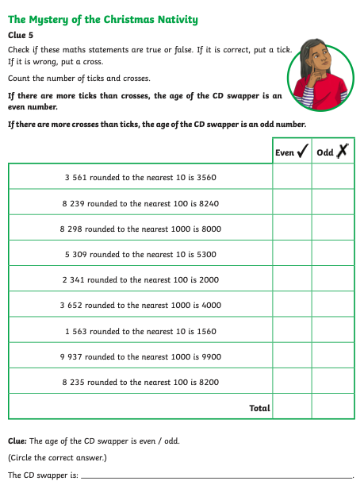
Rounding numbers
You have done this too!
5 or above round up, 50 or above round up and 500 or above round up

3,561 – to the nearest 10 = 3,560 because 1 is below 5.
Nearest 10 end in 0, Nearest 100 end in 00, Nearest 1000 end in 000.
This is your final clue – You should know who is the CD swapper!

