Welsh Challenge Sheet
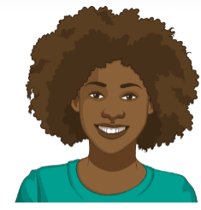
Can you extend you sentence even further?

For example:
- I like to play tennis because I like to play with my friends.
- Dw i’n hoffi chwarae tenis achos dw i’n hoffi chwarae gyda fy ffrindiau.

- Use achos (because) to extend your sentences.
- Use the key vocabulary box below to help extend your sentences.

Extension sentence patterns
- My interests are… Fy niddordebau ydy…
- My interests are dancing. Fy niddordebau ydy dawnsio.

English | Welsh
It’s fantastic. | Mae’n fendigedig.
It’s fun. | Mae’n hwyl.
I like to keep fit. | Dw i’n hoffi cadw’n heini.
It’s interesting. | Me’n ddiddorol.
I like to play with my friends. | Dw i’n hoffi chwarae gyda fy ffrindiau.
I like to get fresh air. | Dw i’n hoffi cael awyr iach.
It’s a good way to relax. | Mae’n ffordd dda i ymlacio.
I like to win! | Dw i’n hoffi ennill!
I am competitive. | Dw i’n gystadleuol.

