Adjectives
Learning objective: To identify and use adjectives correctly.
Task 1: Highlight the adjectives in the sentences below.
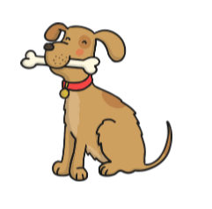
- Tommy was a small dog.

- He had brown, fluffy fur.

- His brown eyes were as brown as a great, oak tree.

- He had a wet, oval shaped nose.

- The beautiful dog was very kind.

- His collar was a ruby red colour with a metal, gold tag.

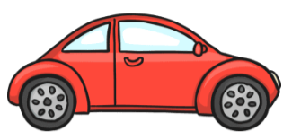
Task 2: Insert adjectives into the sentences below.
- The car.

- The car had doors.

- The car was .

- The wheels on the car were .

- The car was my favourite colour.

Task 3: Taste your favourite food at home and write a sentence about the food using adjectives.

