Adverbs
Learning objective: To identify and use adverbs correctly.
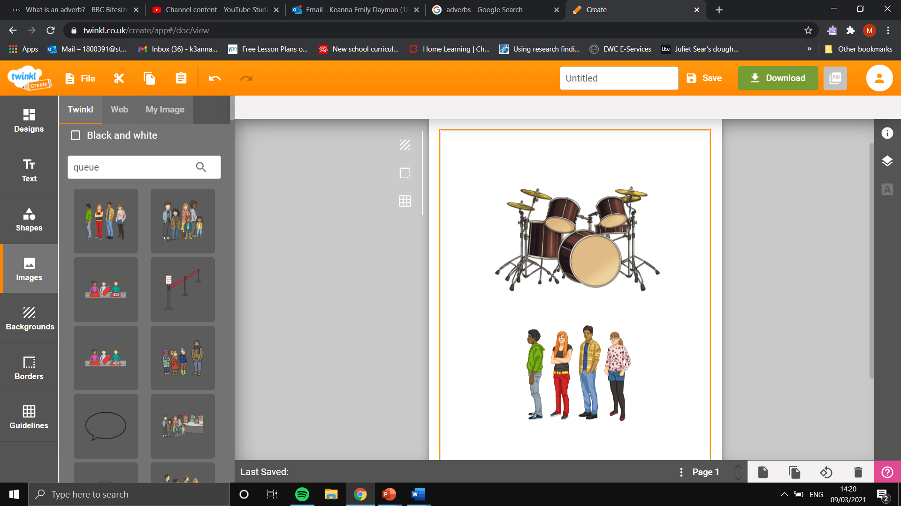
Task 1- Highlight the adverbs in the sentences below.
- He walked quickly to the park.

- She drove her car everywhere.

- He waited in the queue patiently.
- She walked slowly through the busy market.

- He played the drums noisily in his bedroom.

Task 2-Write five sentences that include an adverb.

Task 3- Using a thesaurus, find three other words for the adverbs below.

Quickly

Patiently

Quietly

