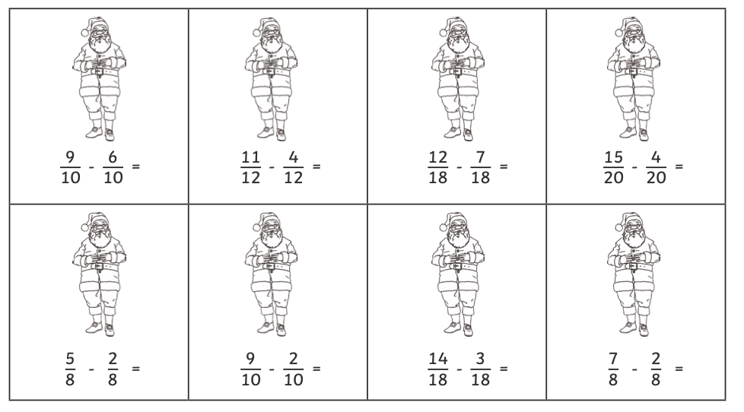
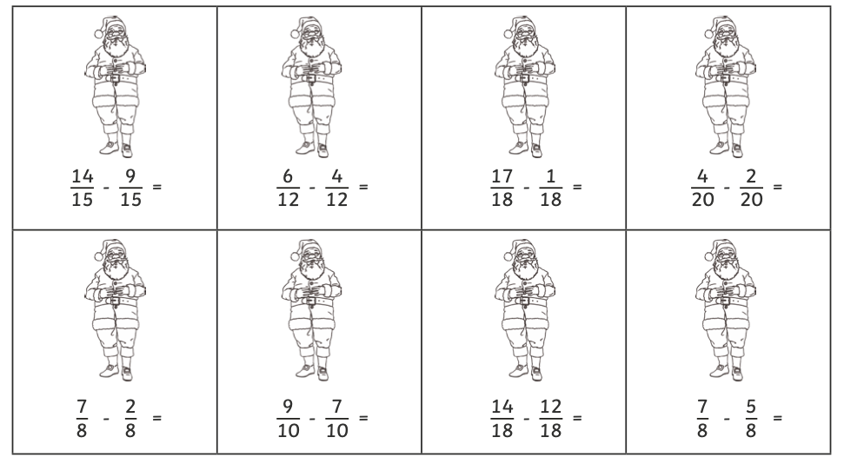
Subtraction of Fractions – with the same denominator.

11/18

7/10

11/20

5/18

7/12

3/10

5/8

3/8
2/8
Or
1/4
2/20
Or
1/10

5/8
2/10
Or
1/5
2/18
Or
1/9
16/18
Or
8/9
2/12
Or
1/6
5/15
Or
1/3

