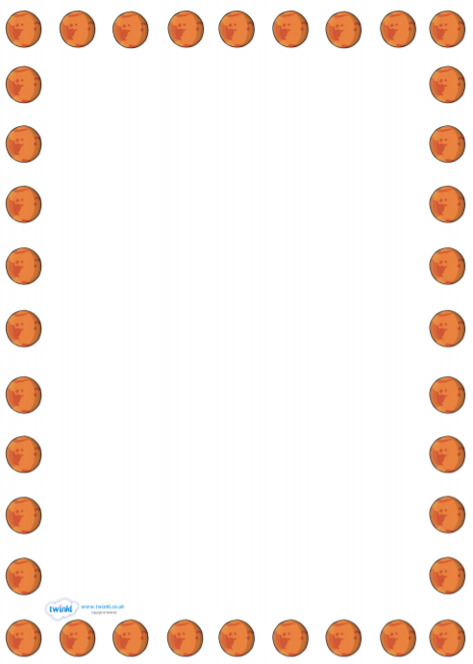
‘Mars’ by Holst’s ‘The Planets'
Learning objective: to understand how ideas and emotions are communicated through music.
How does the piece of music make you feel?
How does the music communicate a military feel and ideas of war?
Use the music as inspiration. What colours does the music make you feel? What shape does the music make you feel? Use these to draw a rocket using these colours and shapes.

