Wednesday word challenge
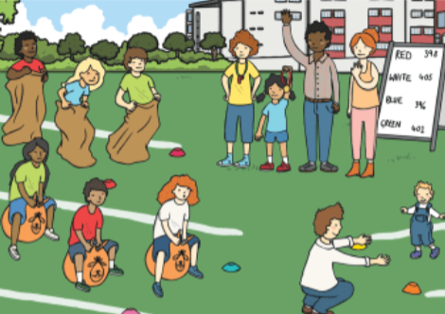
Learning Objective: To identify and use a range of words correctly.
Adjectives
Adjectives
Task: Read through your descriptive piece of writing and improve your adjective using a thesaurus.
Original adjective | Improved word

Adjectives to adverbs
Adjective | Suffix | Adverb
Slow
Crazy
Quick
Quiet
Brave

