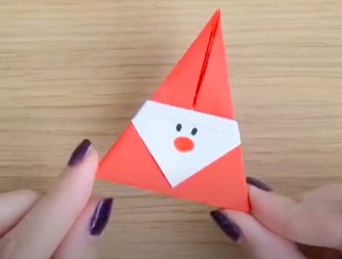
Tuesday 8th December

Literacy Session – Following instructions

In my class on Friday we followed instructions to make our own Father Christmas from paper.

Remember instructions need to be in Chronological order. (Time order)
They need to include Imperative verbs (Bossy verbs) eg cut , slice etc
They sometimes have a list of things you need.
They may use technical language. (Special words)

Watch the video again and try and follow the instructions to make your own Father Christmas

Activity – this video didn’t contain any written instructions can you write your own?

I have created three levels of questions GREEN AMBER RED
(Choose 1 to answer or you can do all three)

I think the best way to answer it is to write your instructions in an email and send it to me
HunterM6@hwbcymru.net
Or
You could write it in a Word document or J2E then share it!
Or
Write it on a piece of paper and ask someone to check it!

GREEN work

- Make a list of all the equipment/things you will need to make Father Christmas.
- Make a list of all the ‘Imperative/Bossy verbs’ you might need to use.
- Have a go at writing your own first instruction. What are you going to tell the reader to do first?

Ideas for Verbs – Fold ,Turn over and Press down.

AMBER work

- Before you start make a list of the everything you will need. Write them down.
If you didn’t have two pieces of paper what could you do?
- Think about the kinds of Imperative verbs that you may need to use. Write them down.
- Have a go at writing your own instructions. ‘How to make an Origami Father Christmas.’
RED work

Write a clear and concise set of instructions.
Remember – You will need.
Clear instructions using ‘Imperative verbs’
If you didn’t have coloured paper – What could you do?
Use ‘Time connectives ‘ to make sure it is in chronological order.

How to make a simple Origami Father Christmas.

You could add some links to other decorations you have found!

Have fun making all your Father Christmas’s. Take a photo and email it to me. I will put it on the website.
You could even make lots of them to make a special paper chain – that would look amazing!

https://youtu.be/SWHYkT4H4_k

