
Wednesday 9th December

Writing a report – Diary writing.

We are in a really difficult time in history, Covid19 has changed our lives and made us do things differently. In 10 years’, time or 20 years’ time this will all be history that children learn about in school.
Your children’s’ children will be talking to their teachers about it.

How will people know what happened to normal people? From Diary entries.

A man called Samuel Pepys lived during the Tudor times in London, he wrote about the plague (Black Death) and the great fire of London in 1666. What know what happened because he left diaries telling us what happened. He even buried his diaries during the great fire so they wouldn’t get destroyed.
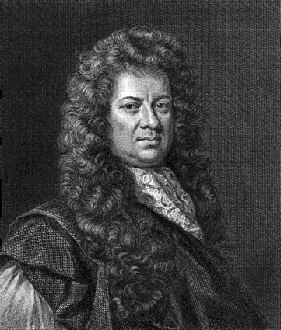

I want you to write your own diary entry for Tuesday 8th December (Yesterday)

- Write about what happened when you woke up. When you found out the news?
- What did you do?
- What did you think? Feel?
- What questions did you ask your parents?

Write it all down -The poster on the next page will help you to think about how to write a diary entry.

Tuesday 8th December.

Dear Diary,



