
Thursday 10th December

Literacy Session – Poetry

Have you watched the videos about snowflakes aren’t they amazing!

Today we are going to write amazing poetry about snowflakes.

We are going to write a short piece of poetry in the form of a Haiku.
A Haiku is a form of Japanese poetry which only has three lines.
The first line has only 5 syllables (small sounds in words)
The second line has 7 syllables
The final line has 5 syllables.
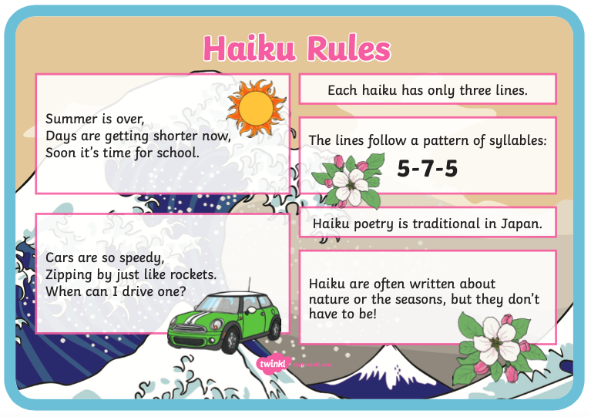

The best way to think about syllables is to write the word down and tick each one.
Example. Snow – 1 tick
Icy. – 2 ticks (I – cy)
Silently – 3 ticks (Si – Lent- Ly)

You can put commas between words to create one line – they don’t need to be a full sentence. Snow, icy, falling, - first line 5 syllables.
Planning your poem.

Use this planning shape – put words around it, feelings, images, colours , images and build up lots of ideas for you to choose from.
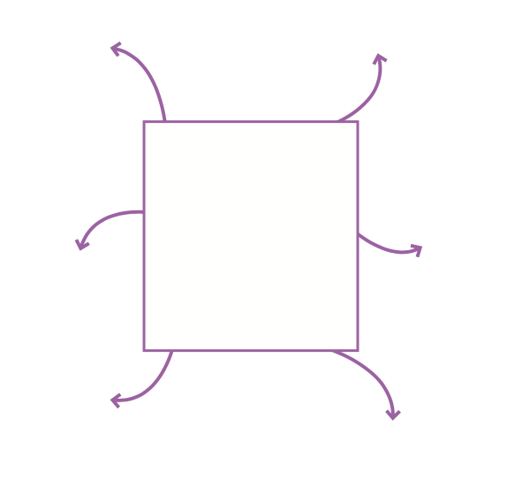
You can draw this on another piece of paper to help you.
Snowflakes
I really look forward to reading you amazing Haikus.
Send them to me – you could add images to them in J2e to make them incredible.
Or
Use adobe spark.
Be creative – Have fun!

