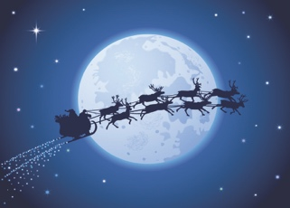
Friday 11th December
This Photo by Unknown Author is licensed under CC BY-SA

Writing a Story– Narrative.

This is my last Literacy lesson for Green Team –
next week Mrs Williams will be taking over. Remember send all Literacy work to her and all Maths work to me!

Thank you!

This is a famous poem called

A Visit from St. Nicholas

'Twas the night before Christmas, when all through the house
Not a creature was stirring, not even a mouse;
The stockings were hung by the chimney with care,
In hopes that St. Nicholas soon would be there;

The children were nestled all snug in their beds;
While visions of sugar-plums danced in their heads;
And mamma in her 'kerchief, and I in my cap,
Had just settled our brains for a long winter's nap,

When out on the lawn there arose such a clatter,
I sprang from my bed to see what was the matter.
Away to the window I flew like a flash,
Tore open the shutters and threw up the sash.

The moon on the breast of the new-fallen snow,
Gave a lustre of midday to objects below,
When what to my wondering eyes did appear,
But a miniature sleigh and eight tiny rein-deer,

With a little old driver so lively and quick,
I knew in a moment he must be St. Nick.
More rapid than eagles his coursers they came,
And he whistled, and shouted, and called them by name:

"Now, Dasher! now, Dancer! now Prancer and Vixen!
On, Comet! on, Cupid! on, Donner and Blitzen!
To the top of the porch! to the top of the wall!
Now dash away! dash away! dash away all!"

As leaves that before the wild hurricane fly,
When they meet with an obstacle, mount to the sky;
So up to the housetop the coursers they flew
With the sleigh full of toys, and St. Nicholas too—

And then, in a twinkling, I heard on the roof
The prancing and pawing of each little hoof.
As I drew in my head, and was turning around,
Down the chimney St. Nicholas came with a bound.

He was dressed all in fur, from his head to his foot,
And his clothes were all tarnished with ashes and soot;
A bundle of toys he had flung on his back,
And he looked like a peddler just opening his pack.

His eyes—how they twinkled! his dimples, how merry!
His cheeks were like roses, his nose like a cherry!
His droll little mouth was drawn up like a bow,
And the beard on his chin was as white as the snow;

The stump of a pipe he held tight in his teeth,
And the smoke, it encircled his head like a wreath;
He had a broad face and a little round belly
That shook when he laughed, like a bowl full of jelly.

He was chubby and plump, a right jolly old elf,
And I laughed when I saw him, in spite of myself;
A wink of his eye and a twist of his head
Soon gave me to know I had nothing to dread;

He spoke not a word, but went straight to his work,
And filled all the stockings; then turned with a jerk,
And laying his finger aside of his nose,
And giving a nod, up the chimney he rose;

He sprang to his sleigh, to his team gave a whistle,
And away they all flew like the down of a thistle.
But I heard him exclaim, ere he drove out of sight—
“Happy Christmas to all, and to all a good night!”

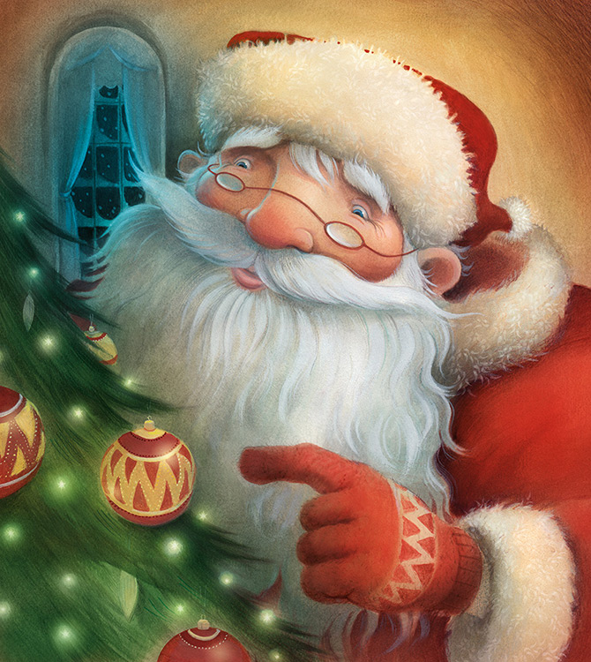

Your task is to take part of this poem and turn it from a Poem into Prose (a story).

You will need to write in full sentences and paragraphs. You could choose the first few verses or the last few. You could focus on the middle part of the poem when the reindeers appear.

It is totally up to you!

Example – this is my idea.

'Twas the night before Christmas, when all through the house
Not a creature was stirring, not even a mouse;
The stockings were hung by the chimney with care,
In hopes that St. Nicholas soon would be there;

The house was silent and still. Everything was ready for tomorrow.
The big day, the special day, Christmas day. The house had been
decorated from top to bottom. There was tinsel everywhere, around
pictures, around doorhandles, even stuck to the ceiling with blutak.
Over the fireplace were big red and green stocking labelled with all
the children’s names, empty and waiting to be filled. Waiting for
Father Christmas, waiting for him to come.

Can you see how I have turned the first verse into a paragraph. The
poem and the paragraph look totally different. However, they are
telling the same part of the story.

Have a go, have fun, Send me your work. I would love to see it!

HunterM6@hwbcymru.net

