Converting Measurements

Learning Objective: To convert between measurements including the use of decimal numbers.
Task 1: Complete the table to convert the measurements in each row.
 | Cm to mm  (x10) | M to cm  (x100) | Km to m  (x1000)
4 | 40 mm | 400 cm | 4000 m
8
7.5
2.1

Task 2: Convert and order the measurements from smallest to biggest in grams.
2 kg | 5.5 kg | 10 kg | 4000 g

Smallest |  |  | Biggest

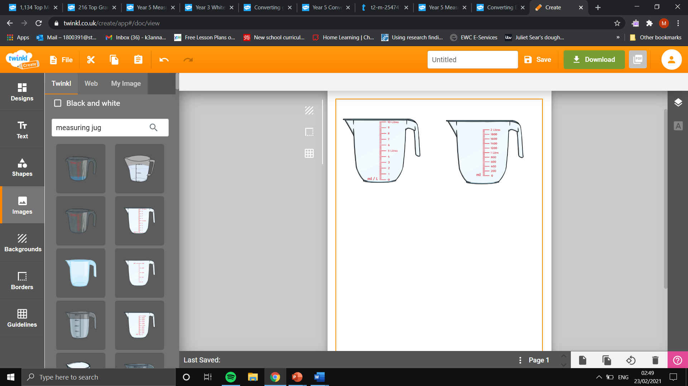
Task 3: Convert and number the measurements from smallest to biggest in millilitres.

Task 4: Read and answer the worded questions below.
- Chief John needs 1.5 kg of flour to bake a cake but the shop only sells flour in grams. Work out the measurement of flour in grams.

- Mary has bought 7 bottles of pop. The bottles have a capacity of 1 litre each. How many millilitres of pop has Mary bought?

- Lewis created an extra-long ruler. The ruler was 6 metres long but how long is this in centimetres?

