Features of a Poem

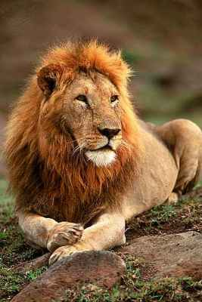
Similes: A simile compares one thing to another.
For example:
- As strong as a lion.
- As proud as a peacock.
- As blue as the sky.

Metaphors: This is a word that is used to describe somethings as if it were another thing.
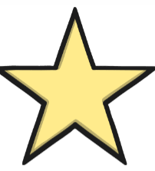
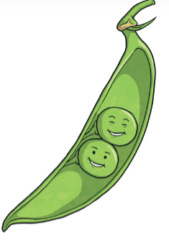
For example:
- John is a star.
- Her hands were ice cubes.
- Those best friends are two peas in a pod.

Alliteration: Alliteration is when words start with the same sound.
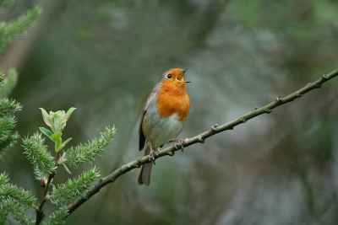
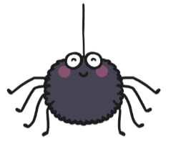
For example:
- Scary spiders.
- Wild waves.
- The round, red robin.

Personification: Personification describes objects as if they are people.
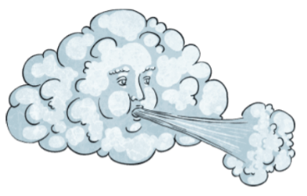
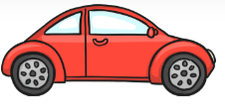
For example:
- The new car danced down the road.
- The lonely lighthouse.
- The wind whistled throughout the night.

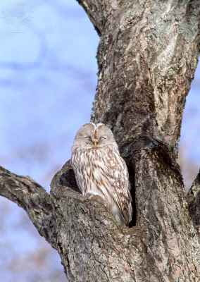
Onomatopoeia: Onomatopoeia is a word that sounds like what it means.
For example:

- The owl hooted in the tree.
- The corn went pop in the microwave.
- The car horn beeped loudly outside.

Features of a Poem
Learning Objective: To listen to and identify the features of a poem.

Come Fall in Love With Swansea Bay
Winter, Spring, Summer or Fall,
Swansea Bay caters for all!
Relax with waterfront drinks to sip,
After taking a scenic boat trip;
There’s Dylan Thomas Center and place of birth,
Or be a board renter and hit Gower surf.
Tour the Peninsular of Gower
With its world ranked beach,
Eat atop Meridian Tower,
All in easy reach.
Museums, waterfalls and sports galore,
And Neath Valley and Canal to explore.
There’s so much to do on any day,
So come fall in love with Swansea Bay.

Poem from https://www.visitswanseabay.com/blog/2015/02/11/poetry-needed-0/

