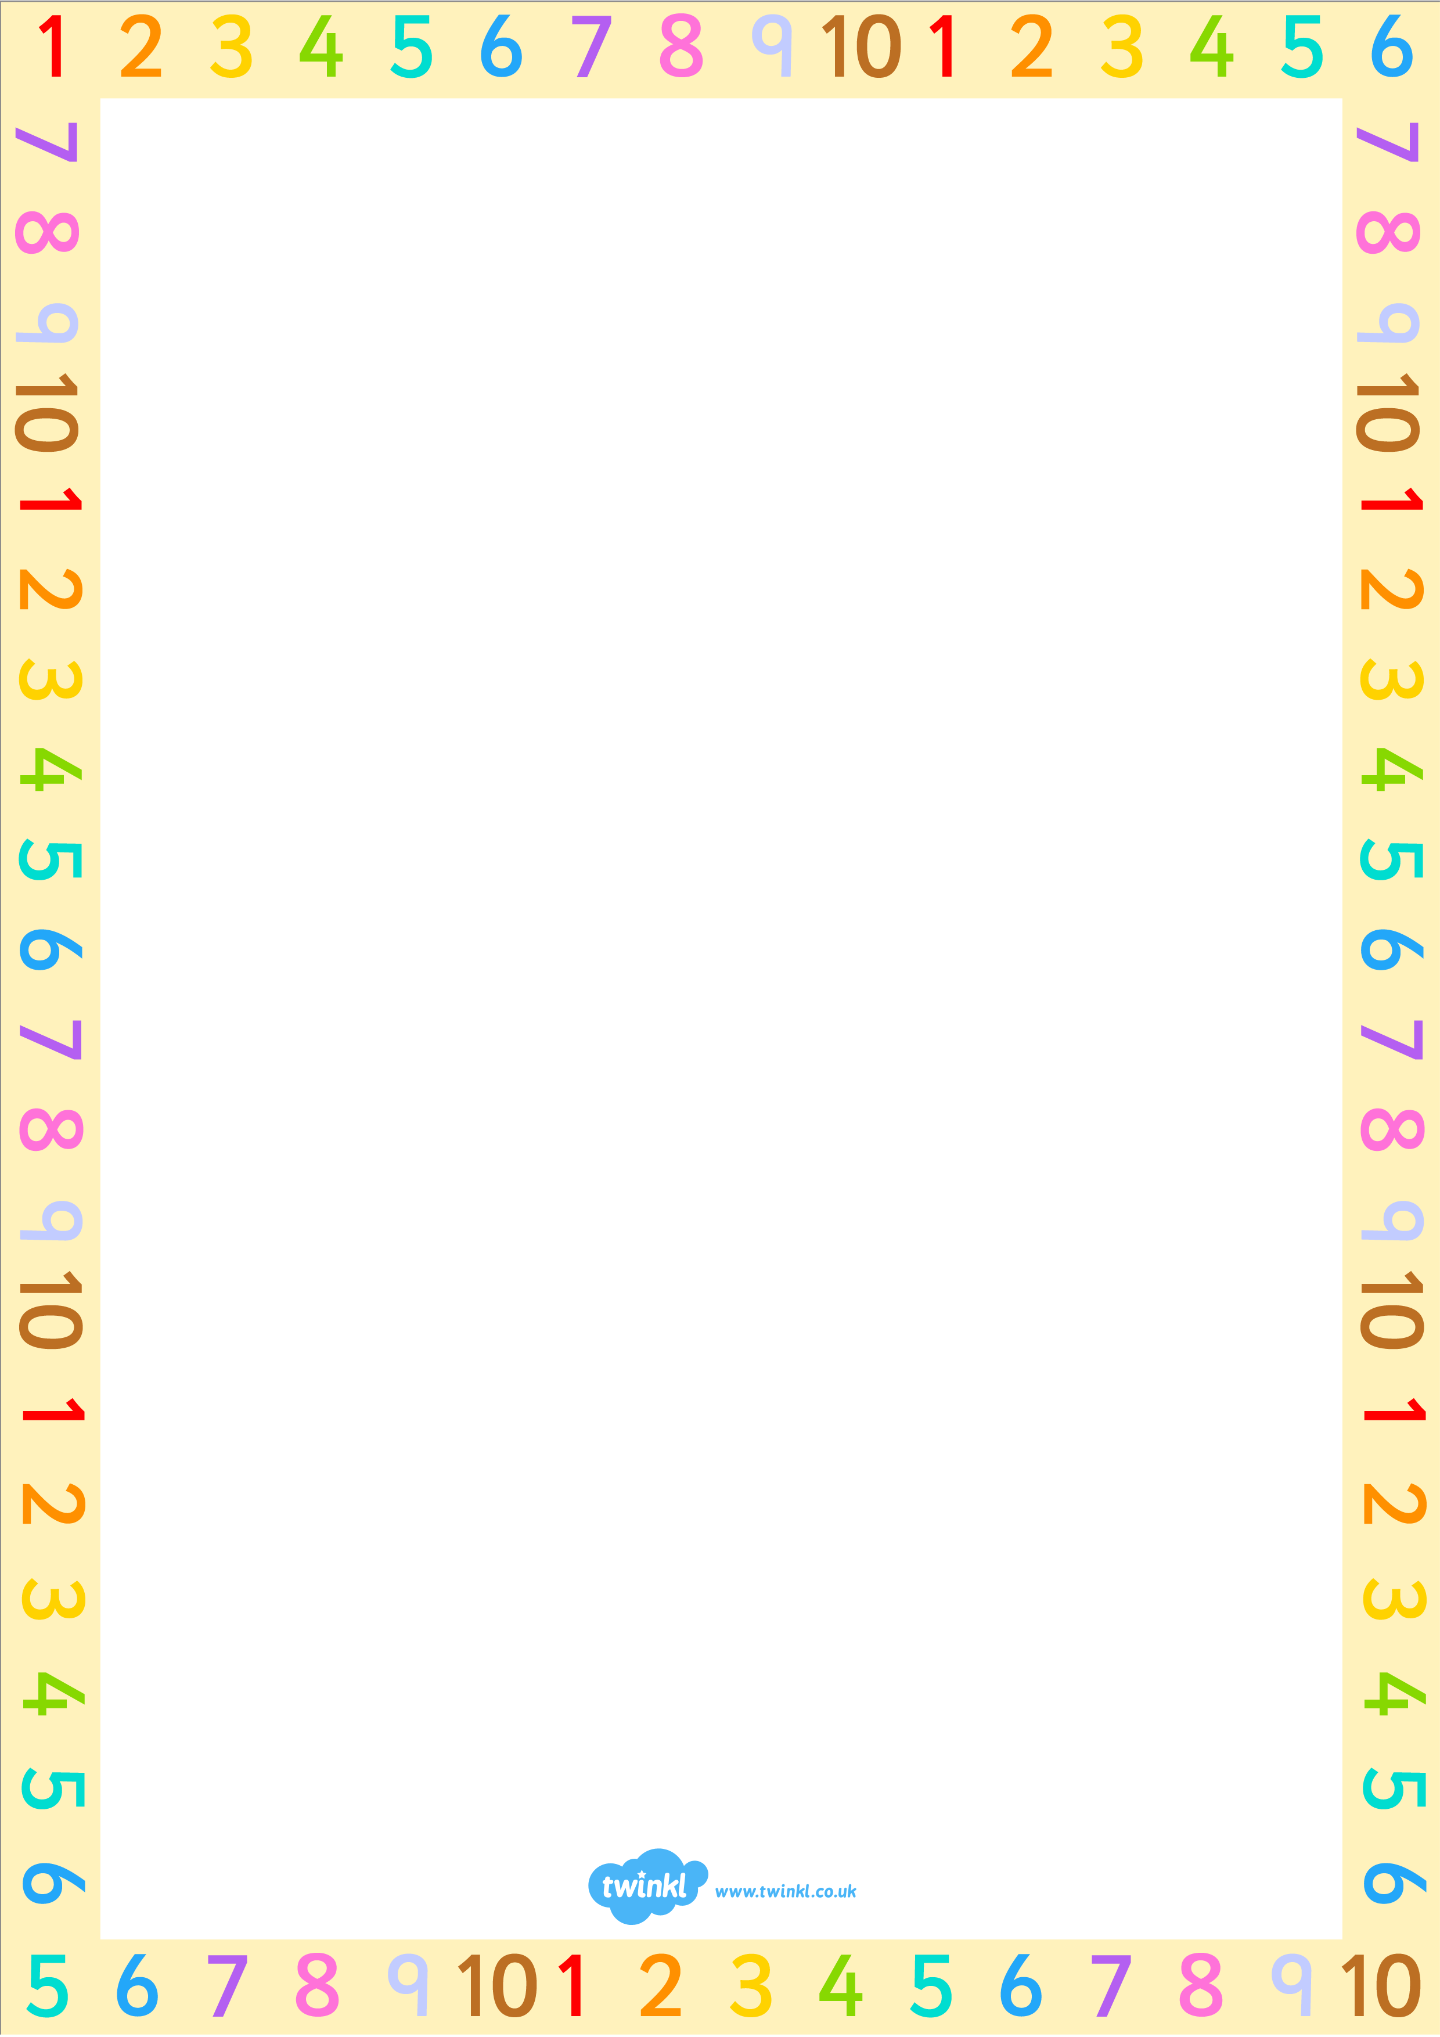
Missing Numbers Example Sheet

Number Bonds
- Number bonds are the parts that make up the whole number.
For example:
- Whole number 10
- Number bonds
- 1 + 9
- 2 + 8
- 3 + 7
- 4 + 6
- 5 + 5
Missing Numbers and Number Bonds
For example:
- 2 + ? = 10
10 is the whole number.
2 is the known part.
What do you add to 2 to make 10?
10 – 2 = ?
10 – 2 = 8
8 is the missing number.

- 15 + ? = 20
20 is the whole number.
15 is the known part.
What do you add to 15 to make 20?
20 – 15 = ?
20 – 15 = 5
5 is the missing number.

- 11 + ? = 50
50 is the whole number.
11 is the known part.
What do you add to 11 to make 50?
50 – 11 = ?
50 – 11 = 39
39 is the missing number.

- 35 + ? = 100
100 is the whole number.
35 is the known part.
What do you add to 35 to make 100?
100 – 35 = ?
100 – 35 = 65
65 is the missing number.

Multiplication Facts and Number Bonds
- 5 x ? = 45
45 is the whole number.
5 is the known part.
What do you multiply 5 by to make 45?
45 $÷$ 5 = ?
45 $÷$ 5 = 9
9 is the missing number.

- 3 x ? = 9
9 is the whole number.
3 is the known part.
What do you multiply 3 by to make 9?
9 $÷$ 3 = ?
9 $÷$ 3 = 3
3 is the missing number.

