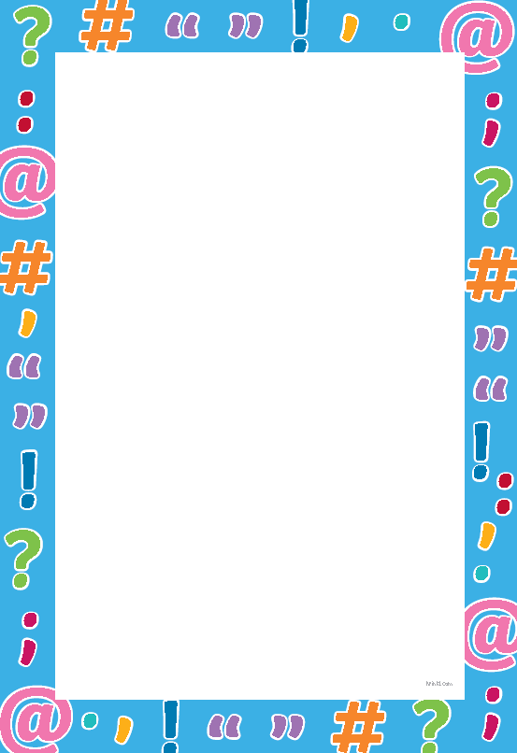
Punctuation

Learning objective: to use a range of punctuation correctly.
Task: correct and write up the sentences below with the correct punctuation.
- i love the beach

- what is your favourite food

- jonny who is very tall passed me the book of the top shelf.

- I am going on holiday in may to germany with my friend tom.

- In the shop I bought cheese flour milk and eggs.

- I was going to buy a cake but the shop has sold out.

- I love sports my favourite is netball

Task: create your own sentences using the punctuation.

