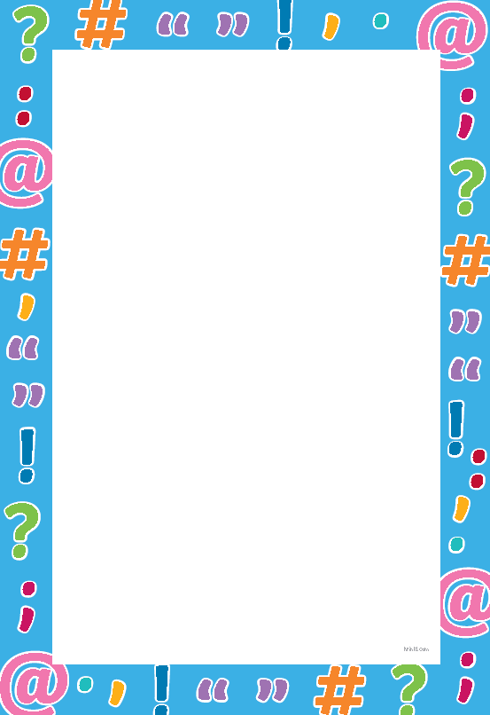
Punctuation

Learning objective: to use a range of punctuation correctly.
Task 1: correct and write out the sentences below using the correct punctuation.

- do you like spain

- i love spain

- i start school starts in september

- Mary who is seven years old does not like roller coasters

- Tom has lots of friends like bob Lewis amy and tina.

- sam was hungry so he was happy to have food early.

Task 2: create your own sentences using the punctuation.

