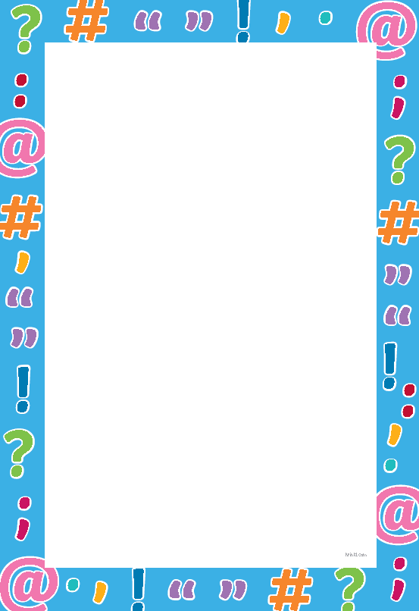
Punctuation Help Sheet
Punctuation | Use | Example
Capital letters  T t | - Capital letters are used at the start of every sentence.  - Capital letters are also used for proper nouns (names of people, places, names of languages, months and days of the week).  - When you are writing about yourself using “I”. The I is always a capital letter. | - Pizza is my favourite food.  - Mary plays football every Saturday.  - I am going to the shop today.
Full stops  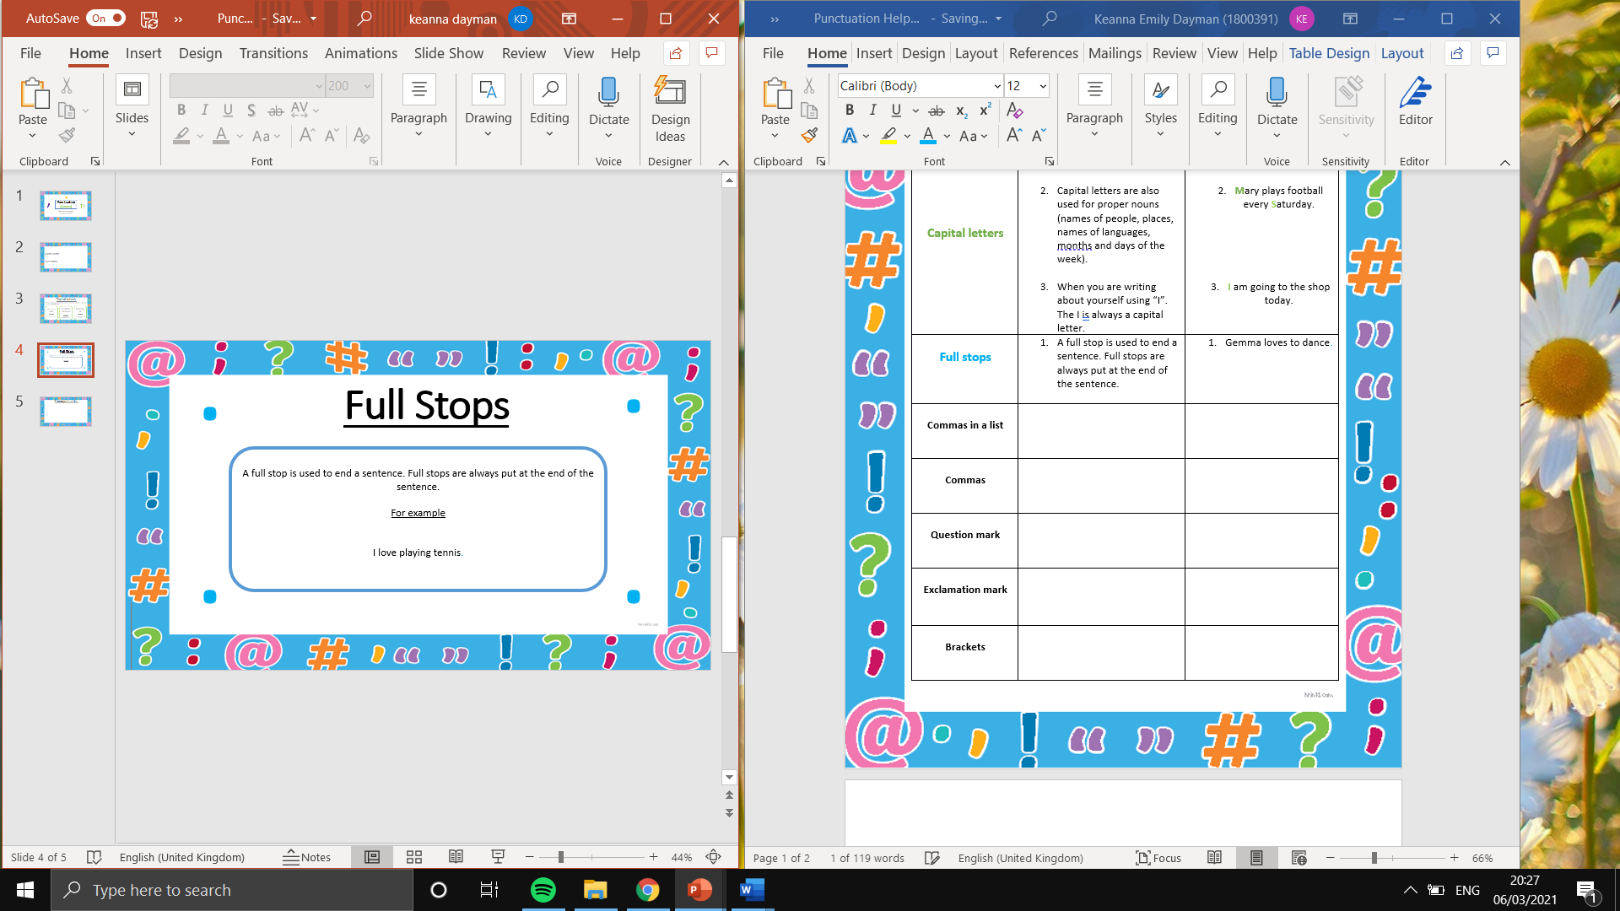 | - A full stop is used to end a sentence. Full stops are always put at the end of the sentence. | - Gemma loves to dance.
Commas in a list  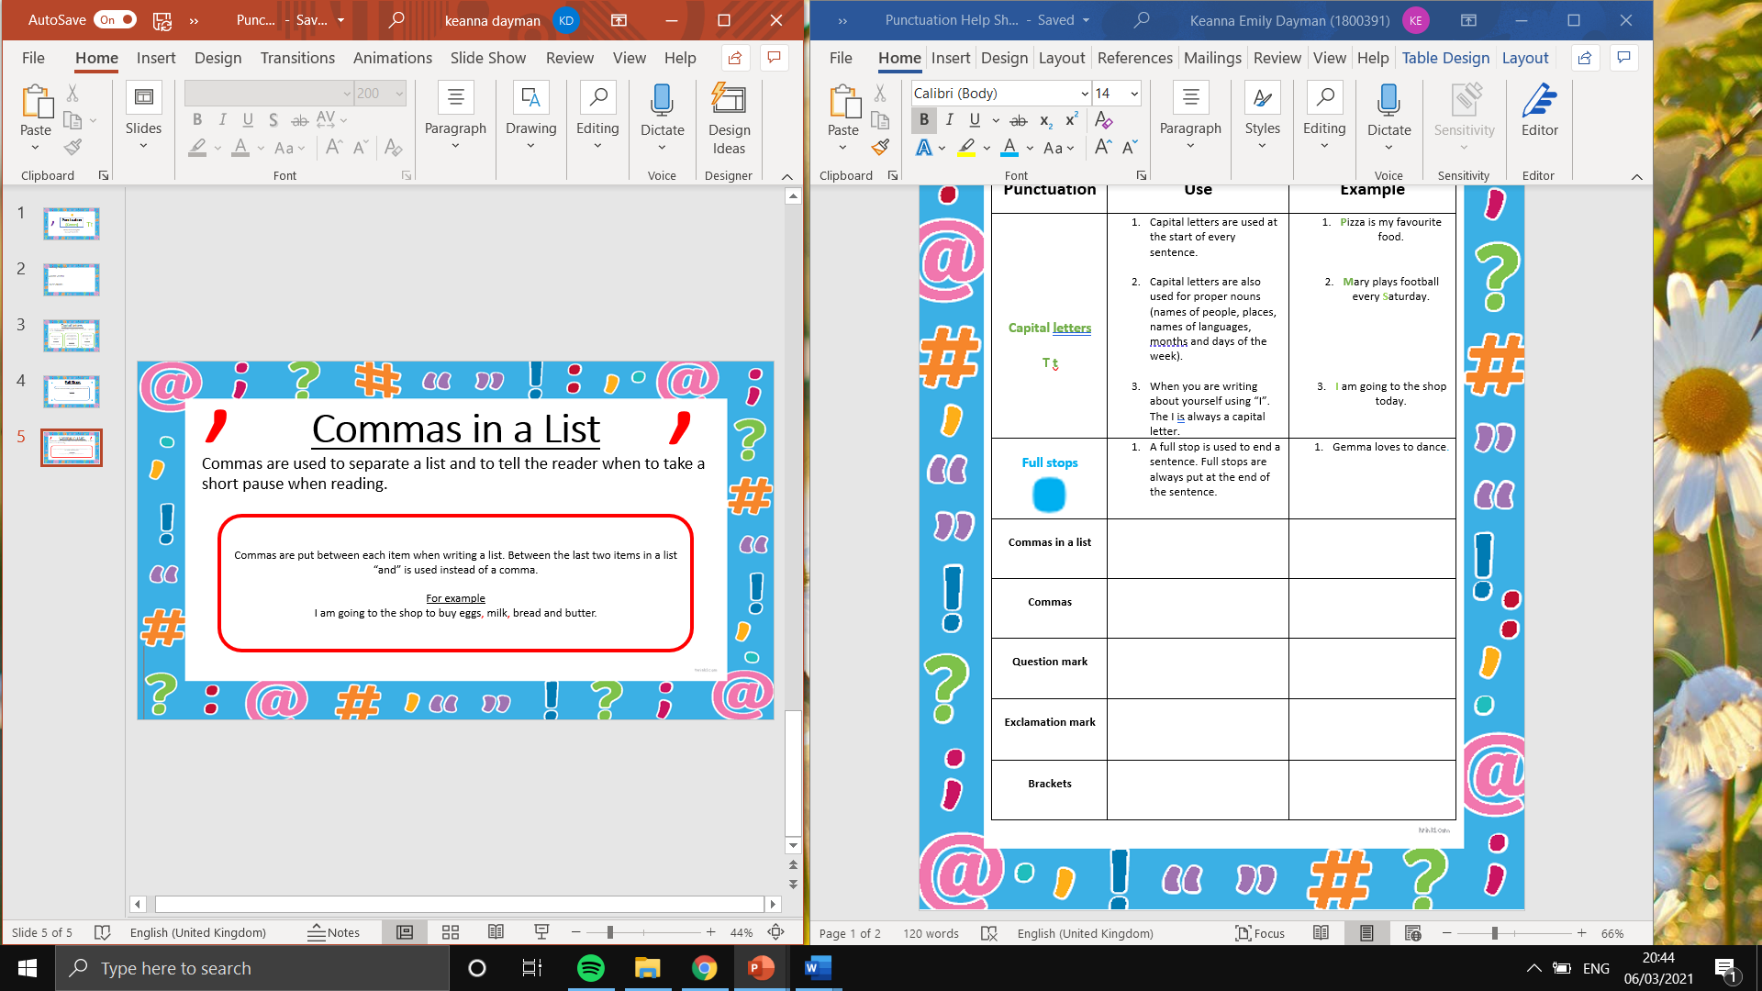 | - Commas are put between each item when writing a list. Between the last two items in a list “and” is used instead of a comma. | - I saw a monkey, penguin, lion and snake at the zoo.
Commas | - Commas can also be used instead of brackets to add extra information.  - Sentences with more than one clause (building blocks of a sentence that include a subject and verb) can also be broken up using commas. | - Lloyd, who is seven, lives in Wales.  - Dylan was hungry, so he was happy to eat dinner.
Question  mark | - Question marks go at the end of every question. | - What is your favourite colour?
?  Exclamation mark  ! | - Exclamation marks are used to show strong feelings like shock, excitement or anger. This lets the reader know to read the sentence with emphasis. | - That was amazing!
Brackets  ( ) | - Brackets are used to add extra information to a sentence. The extra information inside the brackets should make the sentence more informative or interesting. | - Liam (who was very nervous) was about to take a test.
Colon  : | - Colons can be used to introduce an explanation of what was before the colon.  - An expansion of a sentence can also follow a colon.  - A colon can be used to introduce a list. | - He got what he deserved: he really earned that high test mark.  - I love shopping: New Look is my favourite.  - Ffion wanted to visit 3 countries this year: Spain, Italy and Germany.
Semi-colon  ; | - A semi-colon colon links two complete sentences that are connected instead of a full stop separating them. | - We missed too many goals; we lost the game.
Ellipsis  … | - Ellipsis is a row of three dots next to each other. It can be used to create a pause for suspense before the end of the sentence.  - They can also be used to show a thought trailing off. | - I put my favourite cake in the fridge … but it has vanished.  - “I wonder…” said James.


