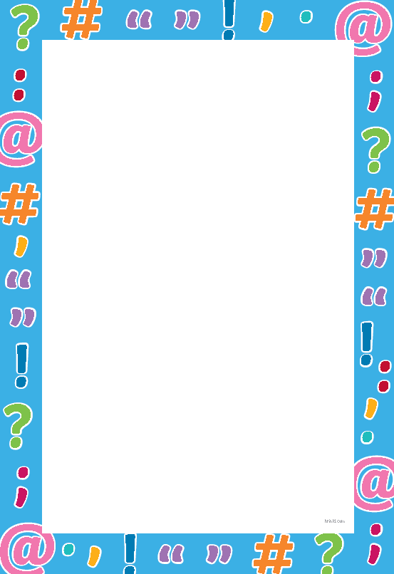
Punctuation

Learning objective: to use a range of punctuation correctly.
Tasks
- Highlight which is not the use of a capital letter.
Proper nouns (like, names of people, places and months) use capital letter.
The letter “I” when it is on its own in a sentence.
Colours are capitalised.
Capital letters are used at the start of a sentence.

- Highlight the missing punctuation and write the sentence with the correct punctuation below.

- i love going to the park.
- i will be going to spain in april until june.
- my dog’s name is ricco
- my favourite subject in school is welsh.
- On Saturday, i am going sam’s house in neath.
- watching football in the liberty stadium is the best

