Methods of Measurement

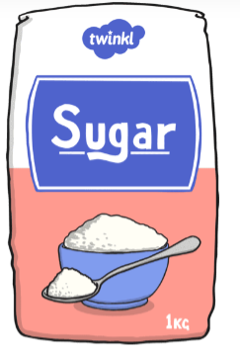
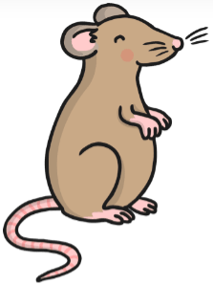
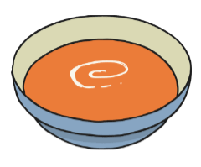
Learning Objective: to understand the different methods to measure using appropriate standard units.

Measuring:
Standard unit of measurement:
Method of measurement:

Measuring:
Standard unit of measurement:
Method of measurement:

Measuring:
Standard unit of measurement:
Method of measurement:

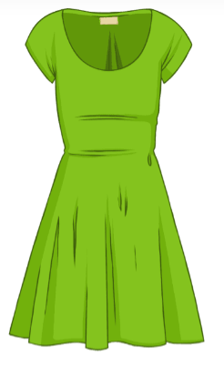
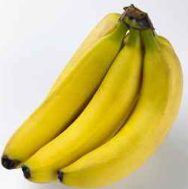
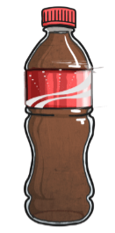

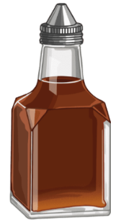
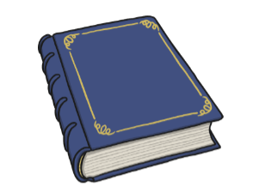
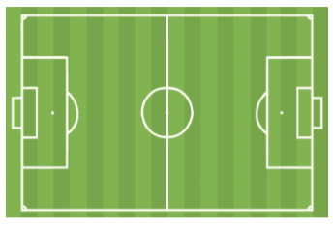
Measuring:
Standard unit of measurement:
Method of measurement:

Measuring:
Standard unit of measurement:
Method of measurement:

Measuring:
Standard unit of measurement:
Method of measurement:

Measuring:
Standard unit of measurement:
Method of measurement:

Measuring:
Standard unit of measurement:
Method of measurement:

Measuring:
Standard unit of measurement:
Method of measurement:

