Methods of Measurement

Learning Objective: to understand the different methods to measure using appropriate standard units.
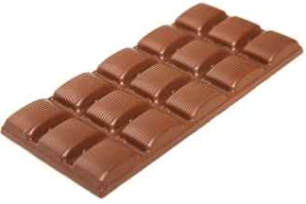
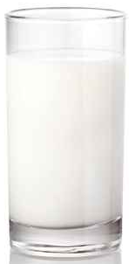
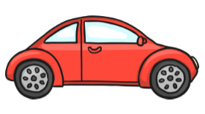

(g/ kg)
Measuring:
Method of measurement:
(mm/ cm/ m/ km)
Measuring:
Method of measurement:

(ml/ l)
Measuring:
Method of measurement:

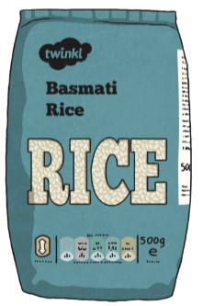
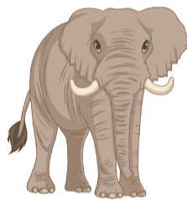
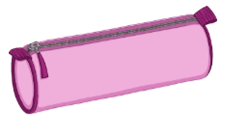

(mm/ cm/ m/ km)
Measuring:
Method of measurement:
(g/ kg)
Measuring:
Method of measurement:
(g/ kg)
Measuring:
Method of measurement:

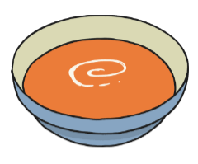




(ml/ l)
Measuring:
Method of measurement:
(ml/ l)
Measuring:
Method of measurement:
(mm/ cm/ m/ km)
Measuring:
Method of measurement:

