Methods of Measurement

Learning Objective: to understand the different methods to measure using appropriate standard units.
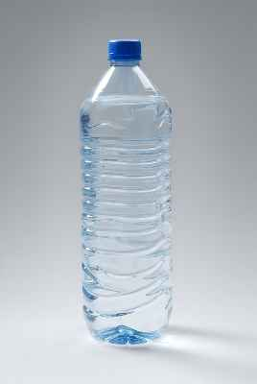
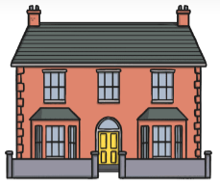
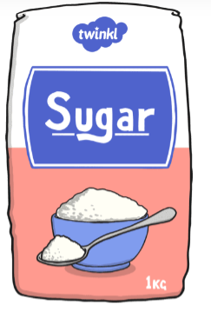

Capacity
(ml/l)
Method of measurement:
Weight/ Mass
(g/kg)
Method of measurement:
Height/ Length
(mm/ cm/ m/ km)
Method of measurement:

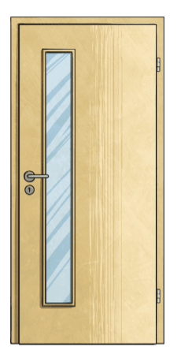
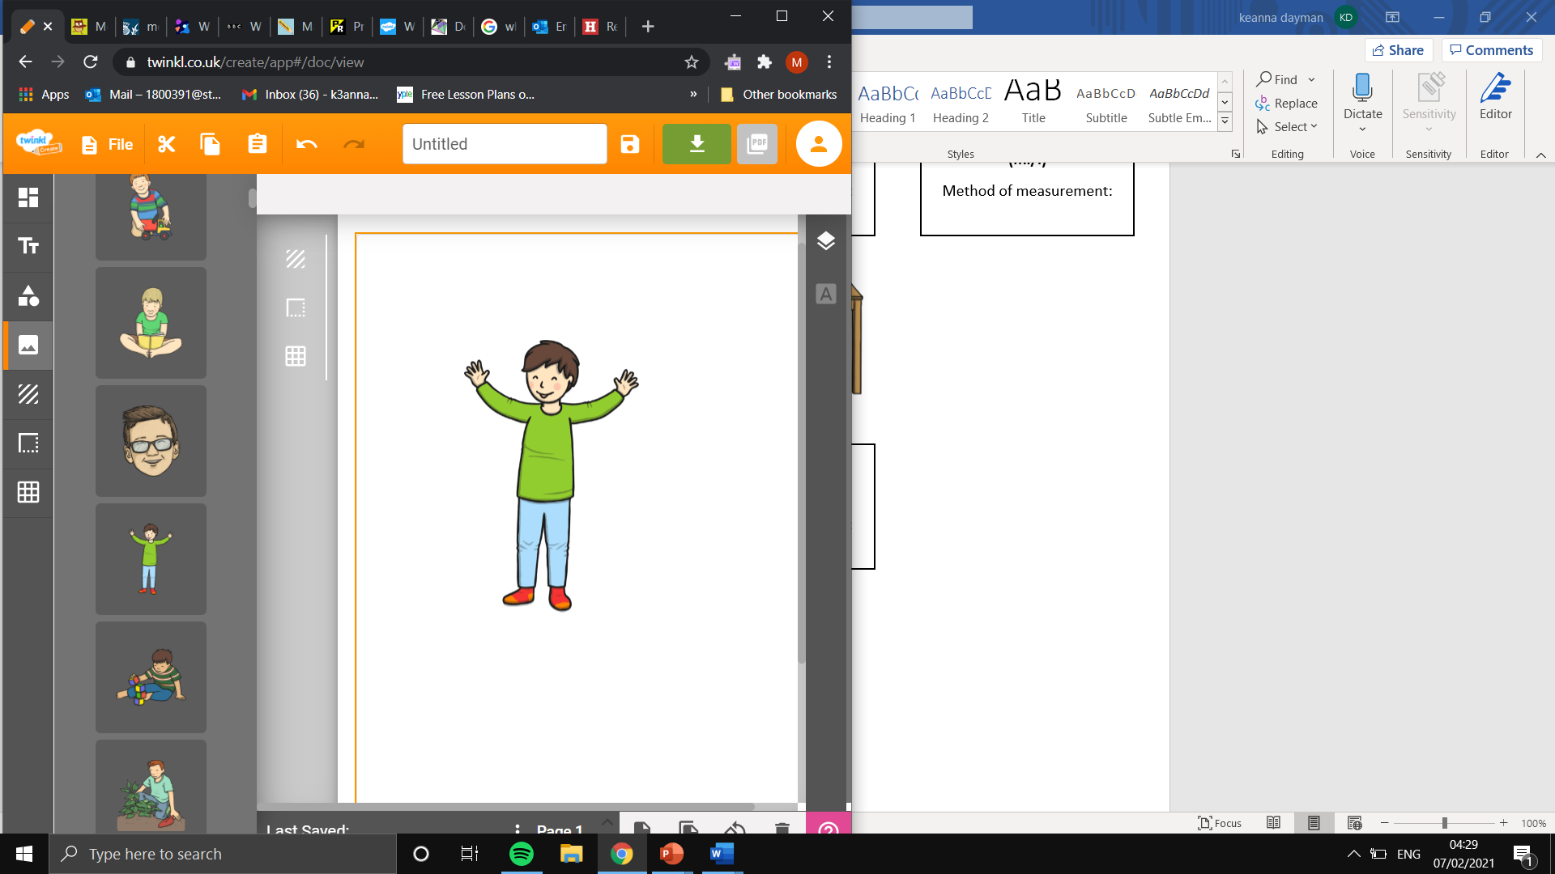
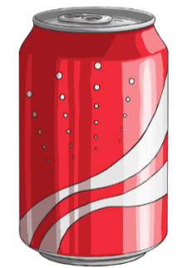

Capacity
(ml/l)
Method of measurement:
Height/ Length
(mm/ cm/ m/ km)
Method of measurement:
Weight/ Mass
(g/kg)
Method of measurement:

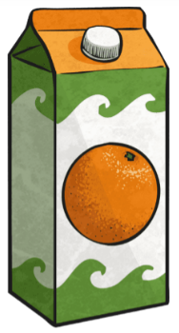
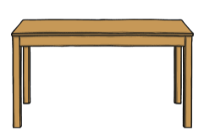

Height/ Length
(mm/ cm/ m/ km)
Method of measurement:
Height/ Length
(mm/ cm/ m/ km)
Method of measurement:
Capacity
(ml/l)
Method of measurement:

