Estimating lengths

Learning Objectives: to estimate and measure length using appropriate standard units.
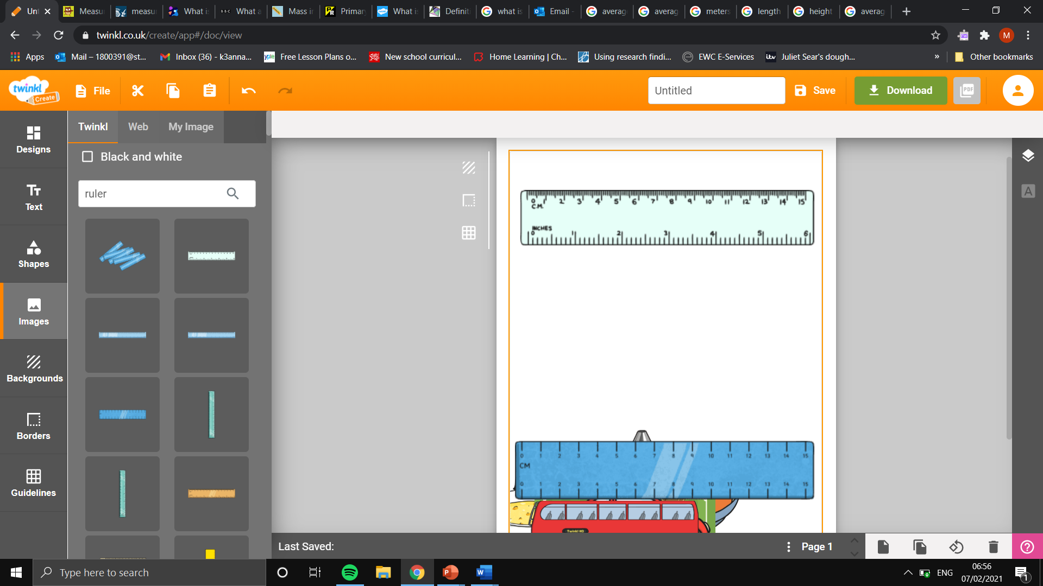
Task: using the ruler, estimate the measurement on the ruler in centimetres.

cm
cm
cm

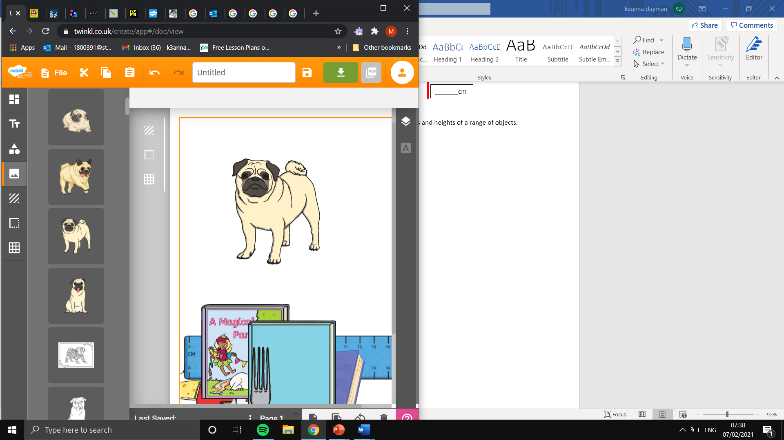
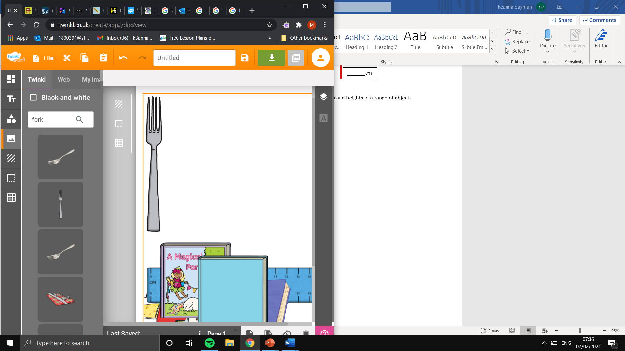
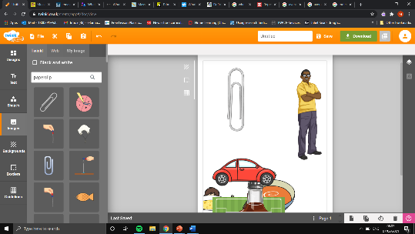
Task: using the measured objects below, estimate the lengths and heights of a range of objects.
Estimated paperclip height: 3.5cm.
Estimated height of a pug in standard units of measurement:
Calculations:
Estimated paperclip height: 3.5cm.
Estimated height of a fork in standard units of measurement:
Calculations:
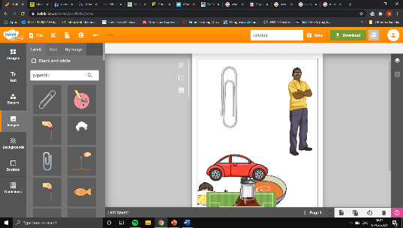
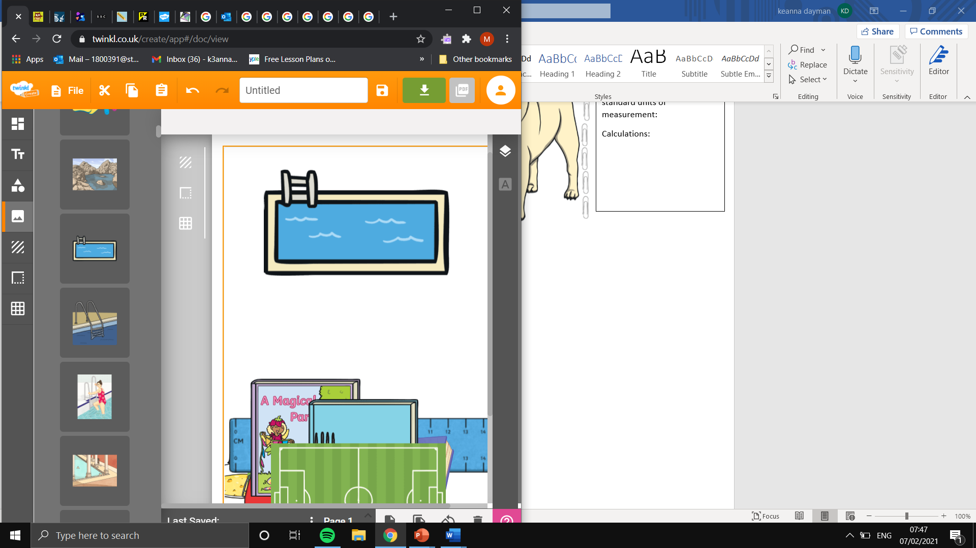
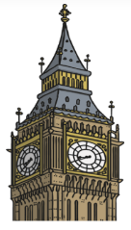
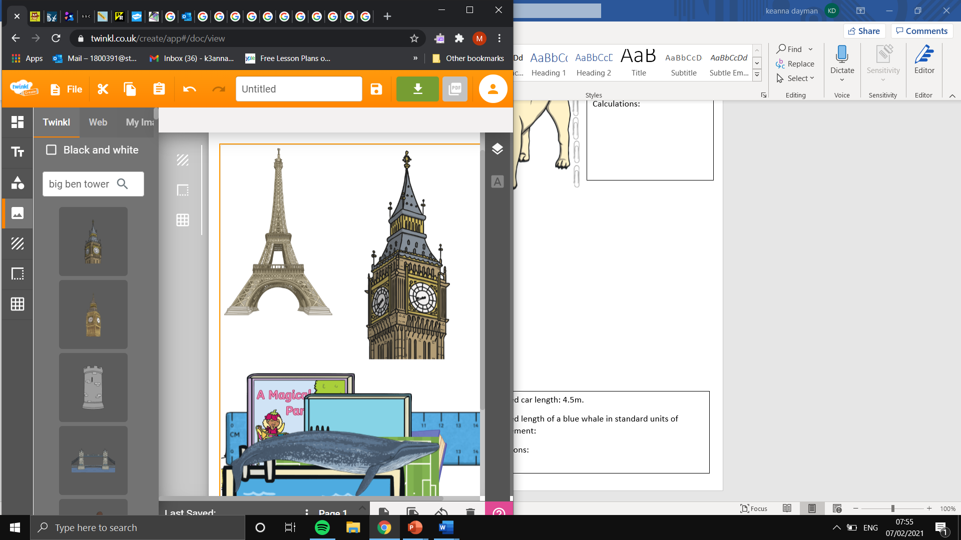
Estimated height of big Ben: 100m.
Estimated height of the Eiffel Tower in standard units of measurement:
Calculations:

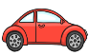
Estimated car length: 4.5m.
Estimated pool length in standard units of measurement:
Calculations:

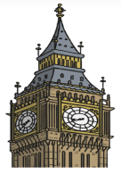

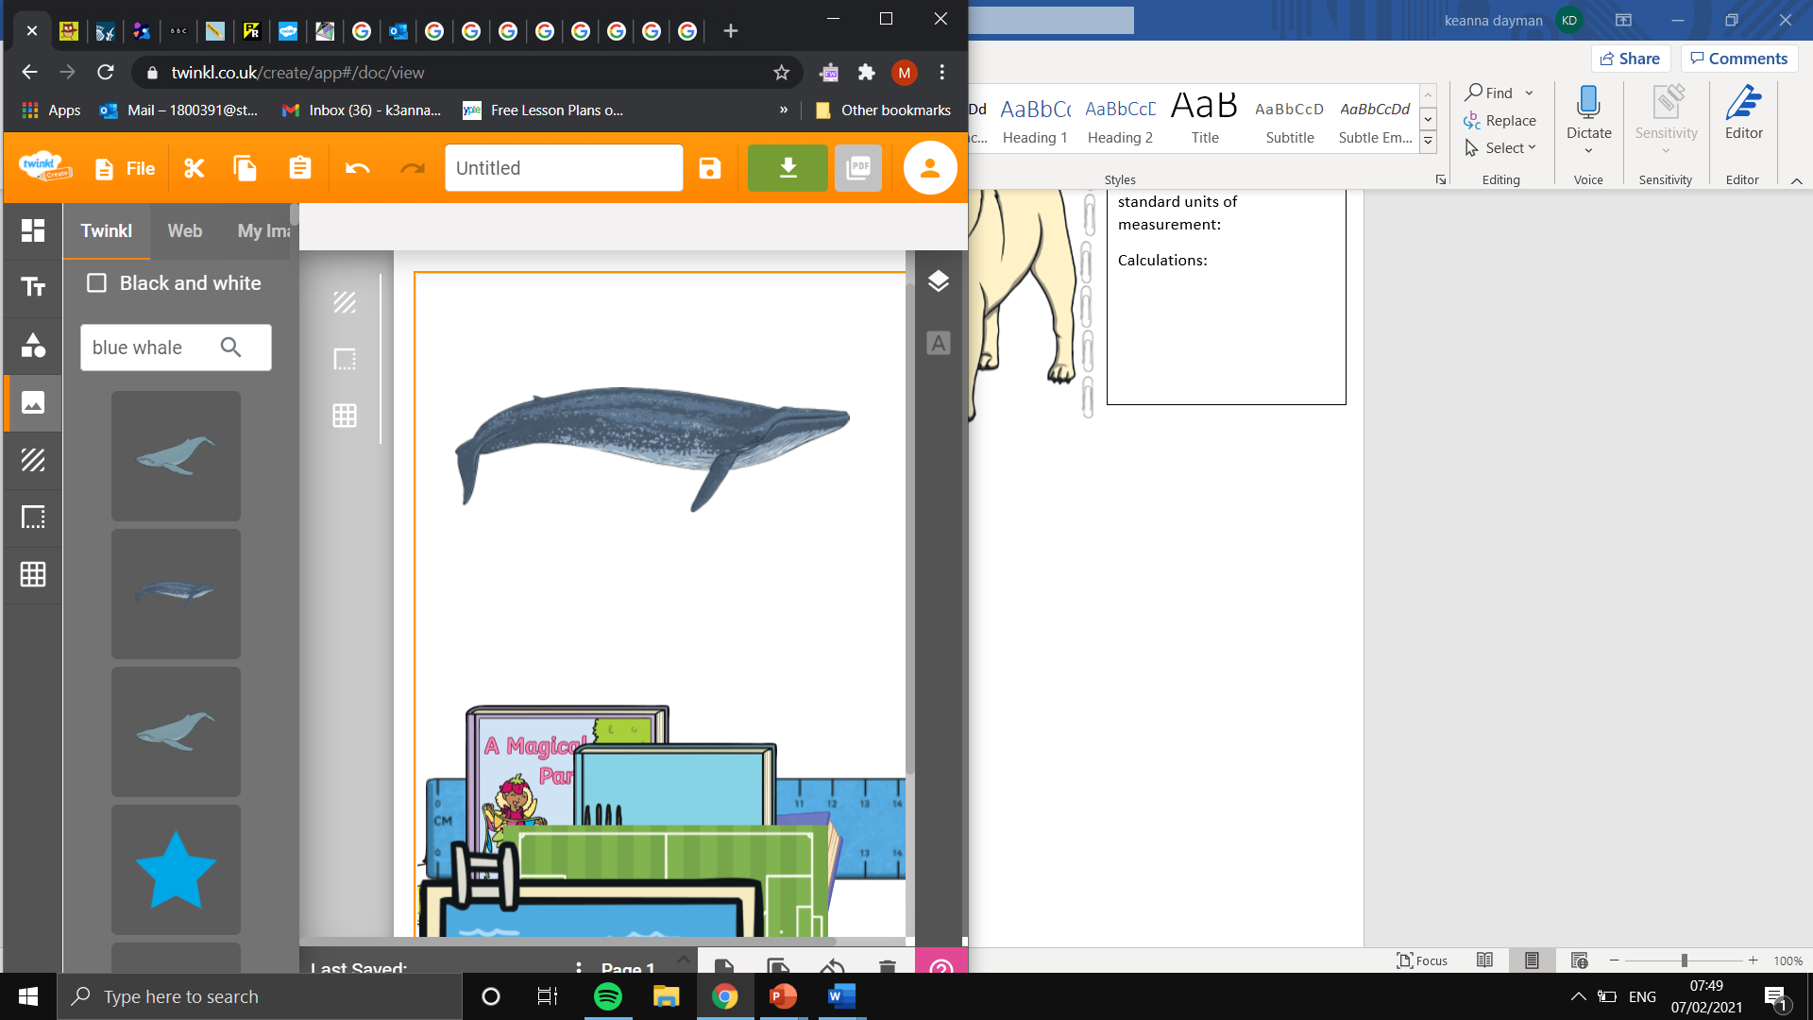
Estimated car length: 4.5m.
Estimated length of a blue whale in standard units of measurement:
Calculations:



