Estimating lengths

Learning Objectives: to estimate and measure length using appropriate standard units.
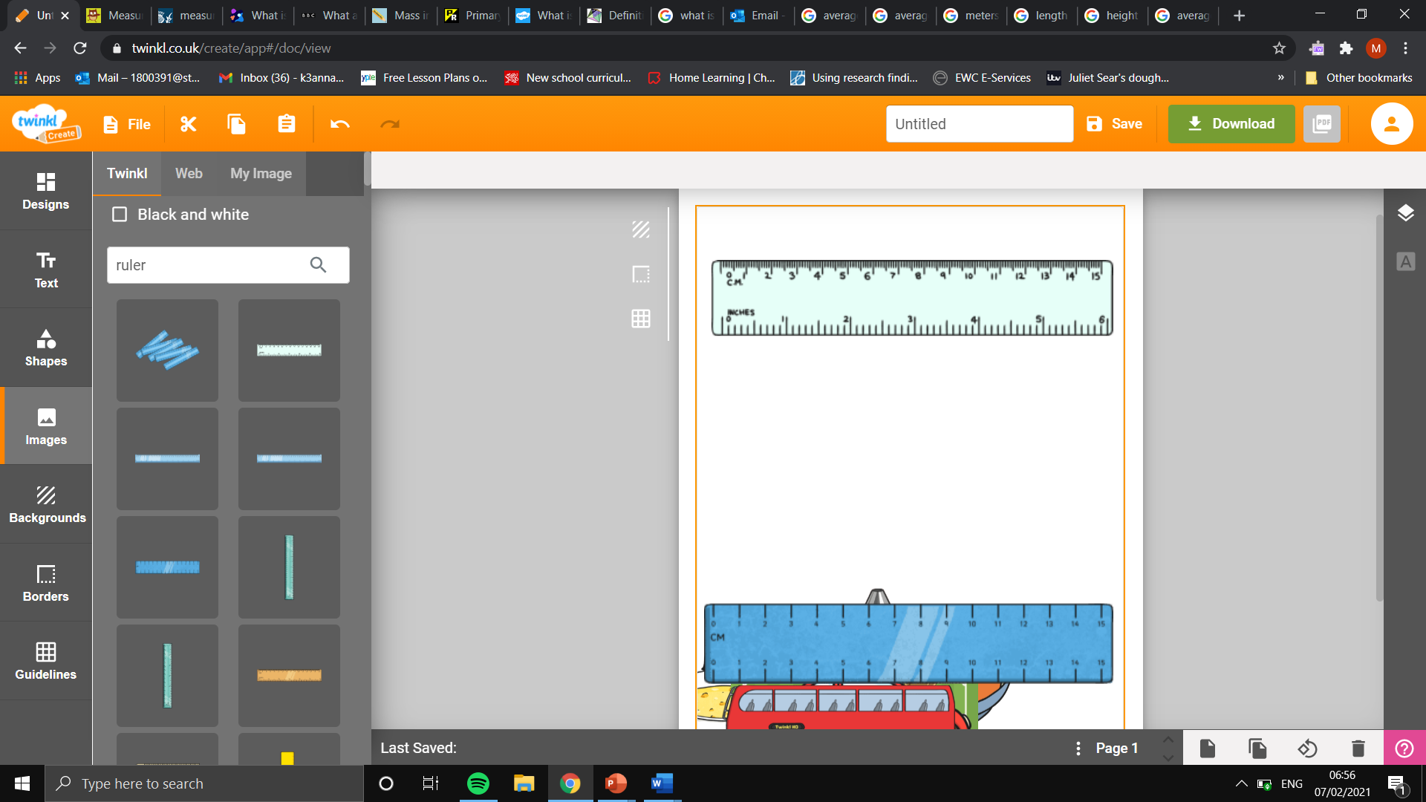
Task: using the ruler, estimate the measurement on the ruler in centimetres.

cm
cm
cm

Task: using the measured objects below, estimate the lengths and heights of a range of objects.
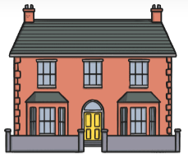
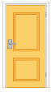
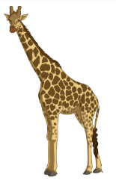
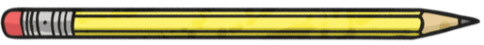
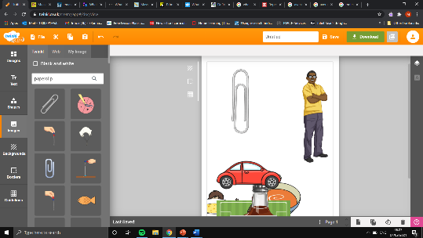
Estimated door height: 2m.
Estimated house height in standard units of measurement:
Calculations:
Estimated door height: 2m.
Estimated height of the giraffe in standard units of measurement:
Calculations:
Estimated paperclip length: 3.5cm.
Estimated height of the giraffe in standard units of measurement:
Calculations:

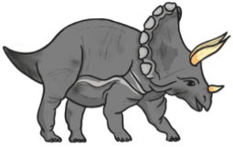
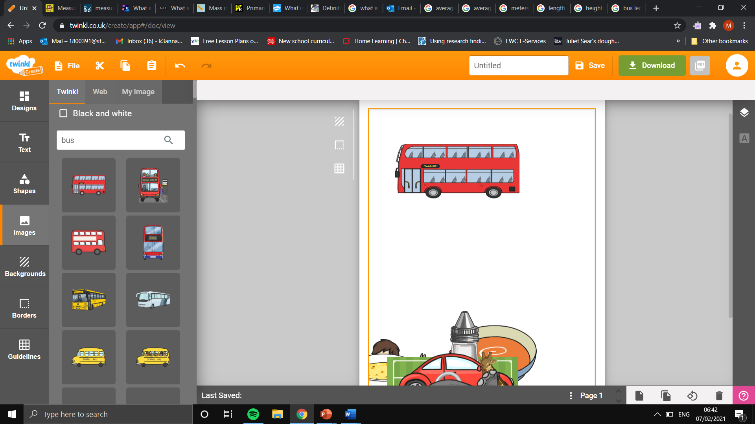

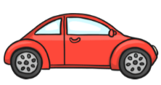
Estimated car length: 4.5m.
Estimated triceratops length in standard units of measurement:
Calculations:
Estimated car length: 4.5m.
Estimated bus length in standard units of measurement:
Calculations:

