Methods of Measurement

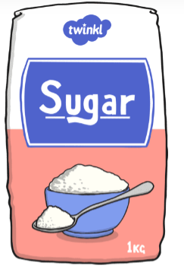
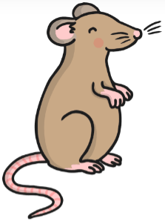
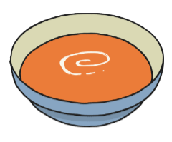
Learning Objective: to understand the different methods to measure using appropriate standard units.

Measuring: Capacity
Standard unit of measurement: (ml/ l)
Method of measurement:
Measuring jug/ cylinder

Measuring: Mass
Standard unit of measurement: (g)
Method of measurement:
Bathroom scale

Measuring: Mass
Standard unit of measurement: (g/ kg)
Method of measurement:
Kitchen scale

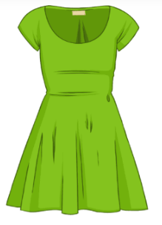
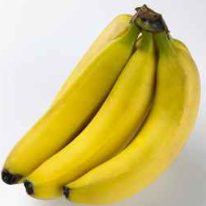
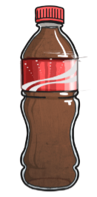

Measuring: Length
Standard unit of measurement: (cm/ m)
Method of measurement:
Measuring tape/ ruler/ metre ruler)

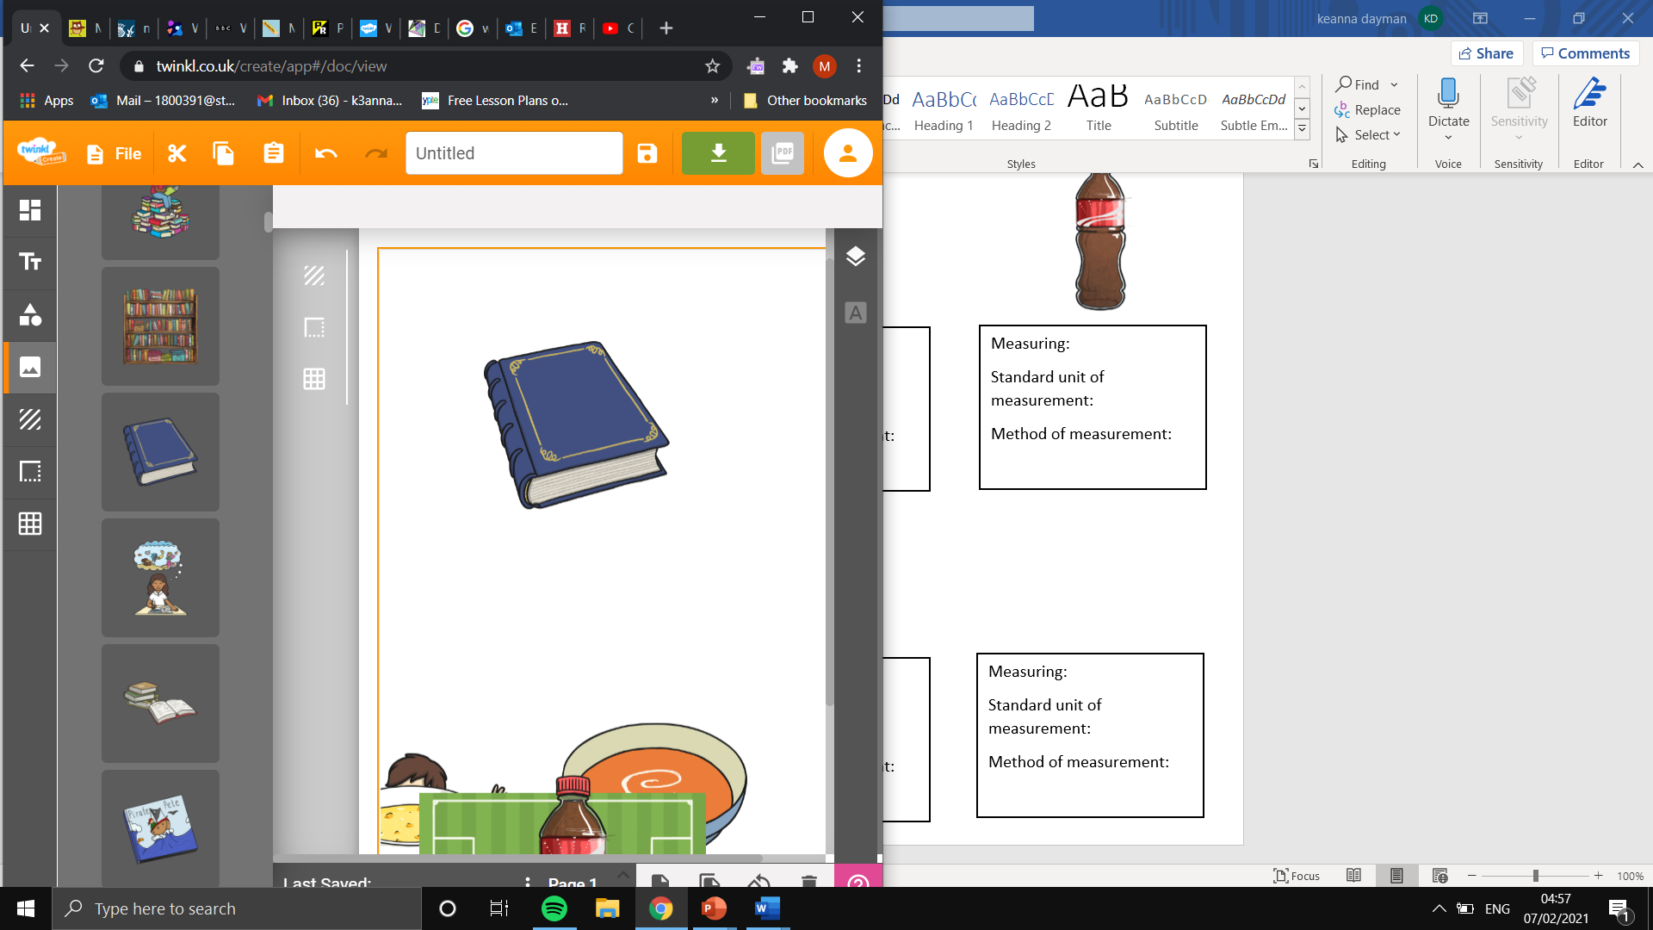
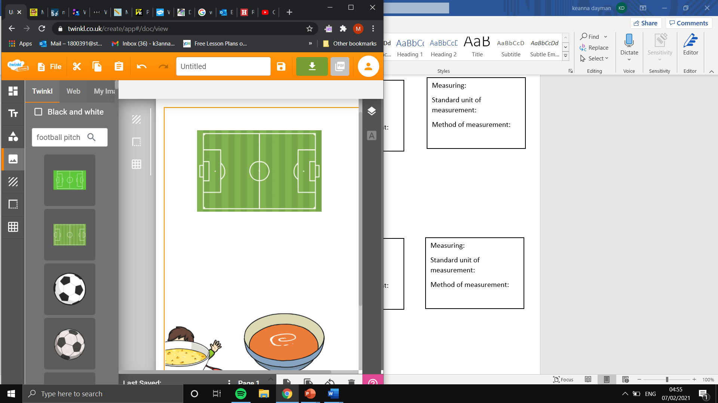
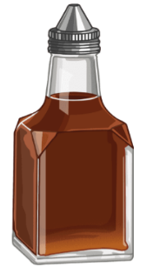
Measuring: Length
Standard unit of measurement: (mm/ cm)
Method of measurement:
Measuring tape/ ruler/

Measuring: Length
Standard unit of measurement:( cm/ m)
Method of measurement:
trundle wheel.

Measuring: Capacity
Standard unit of measurement: (ml/ l)
Method of measurement:
Measuring jug/ cylinder

Measuring: Capacity
Standard unit of measurement: (ml/ l)
Method of measurement:
Measuring jug/ cylinder

Measuring: Mass
Standard unit of measurement: (g/ kg)
Method of measurement:
Kitchen scale

