Methods of Measurement

Learning Objective: to understand the different methods to measure using appropriate standard units.
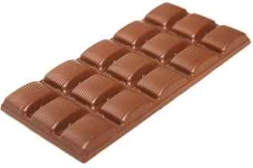
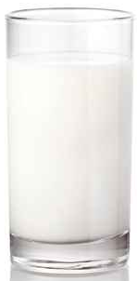
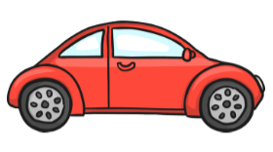

(g/ kg)
Measuring: Mass
Method of measurement:
Kitchen scale

(g/ kg)
Measuring: Mass
Method of measurement:
Bathroom scale / scale

(ml/ l)
Measuring: Capacity
Method of measurement:
Measuring jug/ cylinder

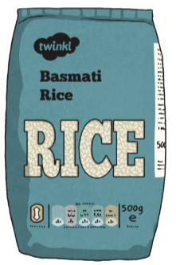
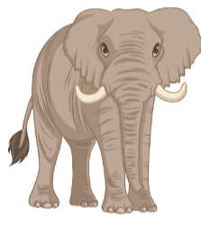
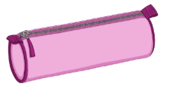

(mm/ cm/ m/ km)
Measuring: Height/ Length
Method of measurement:
Measuring tape/ ruler/

(g/ kg)
Measuring: Mass
Method of measurement:
Kitchen scale

(g/ kg)
Measuring: Mass
Method of measurement:
Huge scale

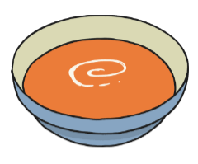
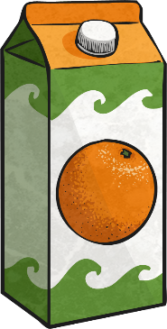

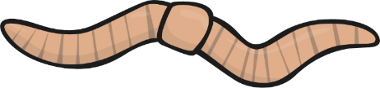

(ml/ l)
Measuring: Capacity
Method of measurement:
Measuring jug/ cylinder

(mm/ cm/ m/ km)
Measuring: Hight/ Length
Method of measurement:
Measuring tape/ ruler/

(ml/ l)
Measuring: Capacity
Method of measurement:
Measuring jug/ cylinder

