Methods of Measurement

Learning Objective: to understand the different methods to measure using appropriate standard units.
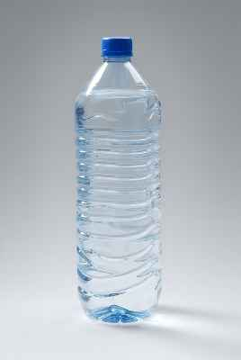
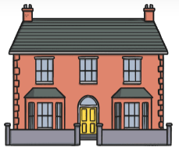
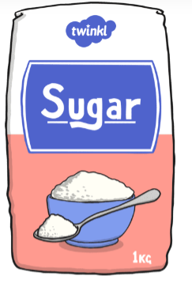

Height/ Length
(mm/ cm/ m/ km)
Method of measurement:
Measuring tape/metre ruler/ trundle wheel.
Capacity
(ml/l)
Method of measurement:
Measuring jug/ cylinder

Weight/ Mass
(g/kg)
Method of measurement:
Kitchen scale

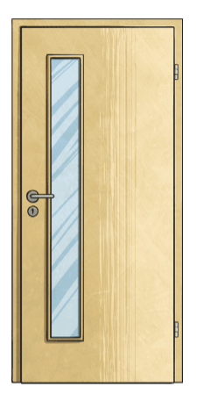
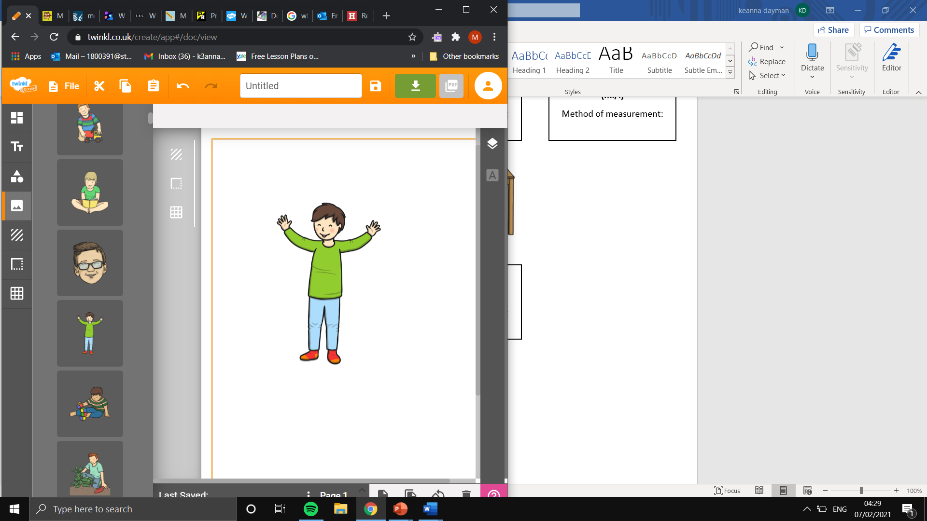
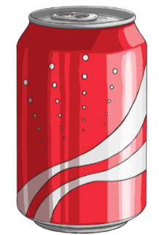

Capacity
(ml/l)
Method of measurement:
Measuring jug/ cylinder
Height/ Length
(mm/ cm/ m/ km)
Method of measurement:
Measuring tape/ ruler/ metre ruler

Weight/ Mass
(g/kg)
Method of measurement:
Bathroom scale

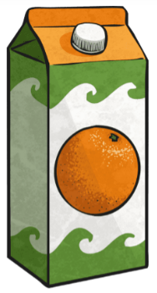
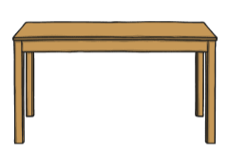

Height/ Length
(mm/ cm/ m/ km)
Method of measurement:
Measuring tape/ ruler/ metre ruler

Height/ Length
(mm/ cm/ m/ km)
Method of measurement:
Measuring tape/ ruler/ metre ruler

Capacity
(ml/l)
Method of measurement:
Measuring jug/ cylinder

