Mass and Capacity

Learning Objective: To estimate and measure mass and capacity using appropriate standard units.
Task: Measure the number of millilitres, litres, grams or kilograms using each method of measurement.
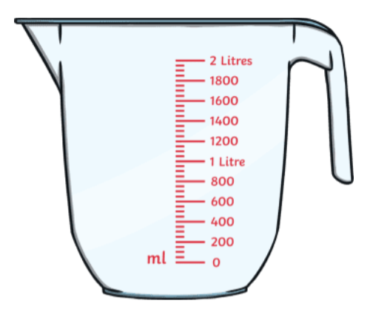
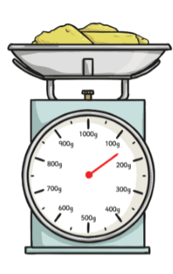
Method of measurement:
Unit of measurement:
Measurement:
L=
ml=
Method of measurement:

Unit of measurement:

Measurement:

Method of measurement:
Unit of measurement:
Measurement:
L=
ml=



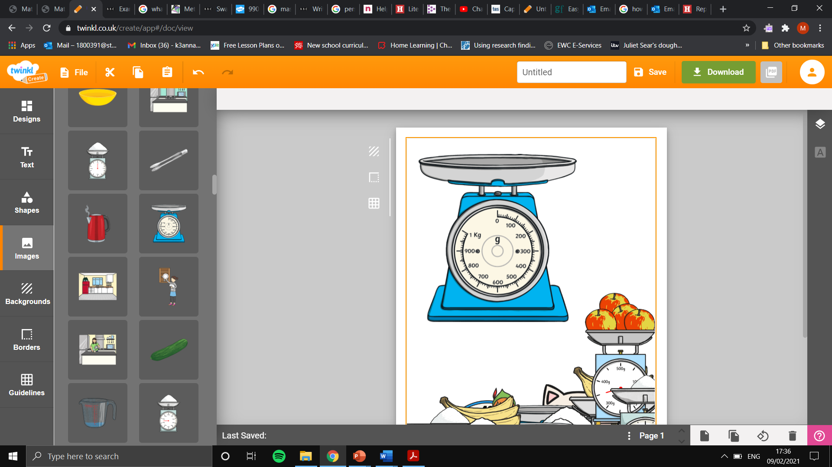
Method of measurement:

Unit of measurement:

Measurement:
Method of measurement:
Unit of measurement:
Measurement:
L=
ml=

Method of measurement:
Unit of measurement:
Measurement:
L=
ml=

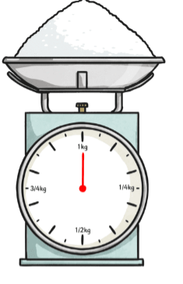
Method of measurement:

Unit of measurement:

Measurement:
Kg=
g=
Method of measurement:
Unit of measurement:
Measurement:
ml=

