REMEMBER
1 cm. = 10 mm (Multiply by 10)
1m = 100 cm (Multiply by 100)

Converting Measurements – AMBER Task
- 5cm = mm

- 7cm = mm

- 23 cm = mm

- 28 cm = mm

- 2 m = cm

- 8 m = cm

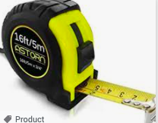
- 22cm = mm

- 18m = cm

- 35 cm = mm

- 21 m = cm

- 2.3 cm = mm

- 8.4 cm = mm

- 13.5 cm = mm

- 2.7m = cm

- 8.3 m = cm

- 12.1 cm = mm

- 18.2 m = cm

